# Overview

This document contains the necessary information to build a one handed modification for the Xbox Series X|S Controller.

Contents

Overview 1

Maker Checklist 2

Maker To Do List 2

Items to Give to User 2

Tool List 2

Customization Guide 3

3D Printing Guide 4

3D Printing Summary 4

3D Printing Settings 4

Post-Processing 4

Examples of Quality Prints 5

Assembly Guide 14

Required Components 14

Required Tools 15

Required Personal Protective Equipment (PPE) 15

Assembly Instructions 16

Step 1 **Error! Bookmark not defined.**

Step 2 **Error! Bookmark not defined.**

Step 3 **Error! Bookmark not defined.**

Testing 16

# Maker Checklist

This list provides an overview of the steps required to build and deliver the device.

## Maker To Do List

* Read through the Assembly Guide to become familiar with required components, tools, supplies, and safety gear and overall assembly steps.
* Talk to User about customization options (e.g., colour, shoe vs leg strap, hook and loop strap size, etc.)
* Gather tools, supplies, and safety equipment.
* Assemble the device
* Test device
* Print “User Quick Guide”

## Items to Give to User

* Assembled, tested device
* “User Quick Guide”

# Tool List

* Flush cutters or scissors
* Sandpaper (optional)
* Superglue (optional)
* Drill and 5/64” drill bit (optional)

# Customization Guide

The user may request the “shoe” or leg strap for controlling the joystick of the unused hand. If the user requests the “shoe”, the original designer recommends printing it with TPU is possible. If printing in TPU is not possible, we recommend adding rubber bands around the “shoe” to increase grip, as shown below.

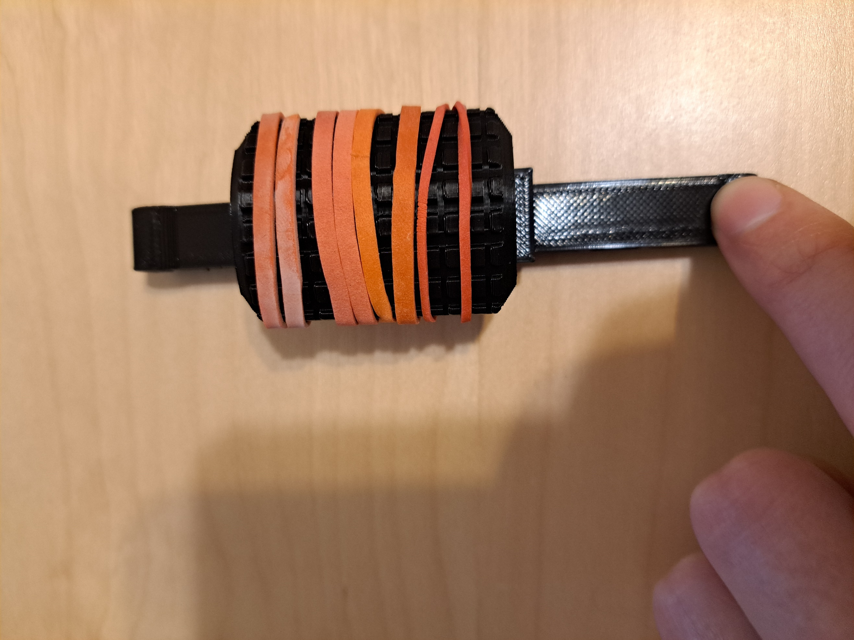

If the user requests the left handed modification, you may add the Button Decorations, ideally in a different colour from the rest of the device for colour contrast. The Button Decorations are a separate .slt file and include A, B, X, Y, and the Xbox logo. The controller with and without the Button Decorations is shown below.

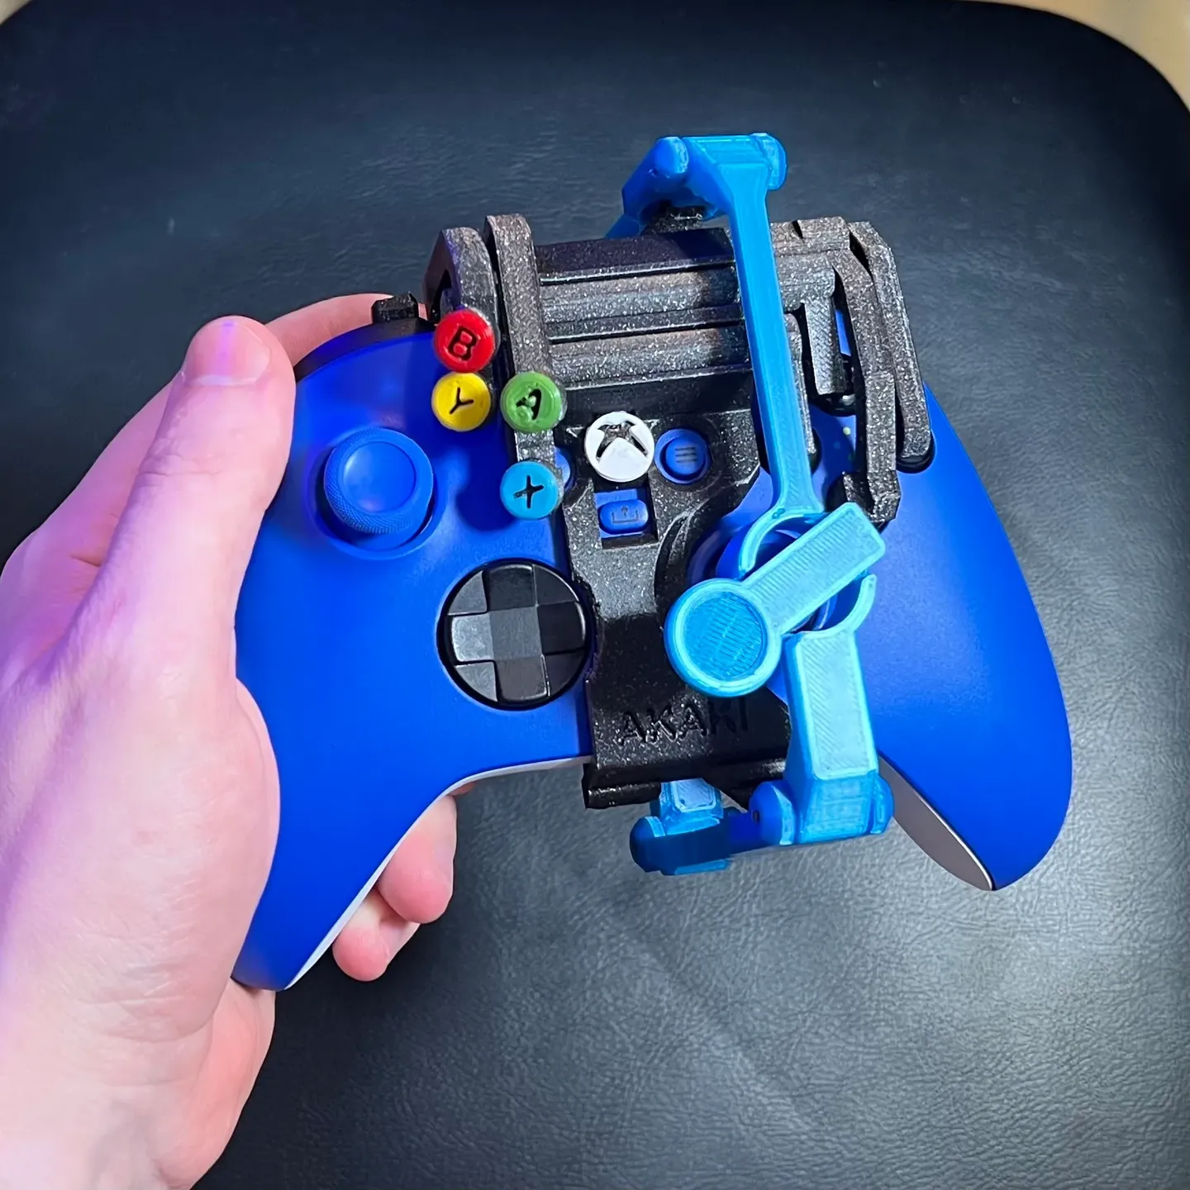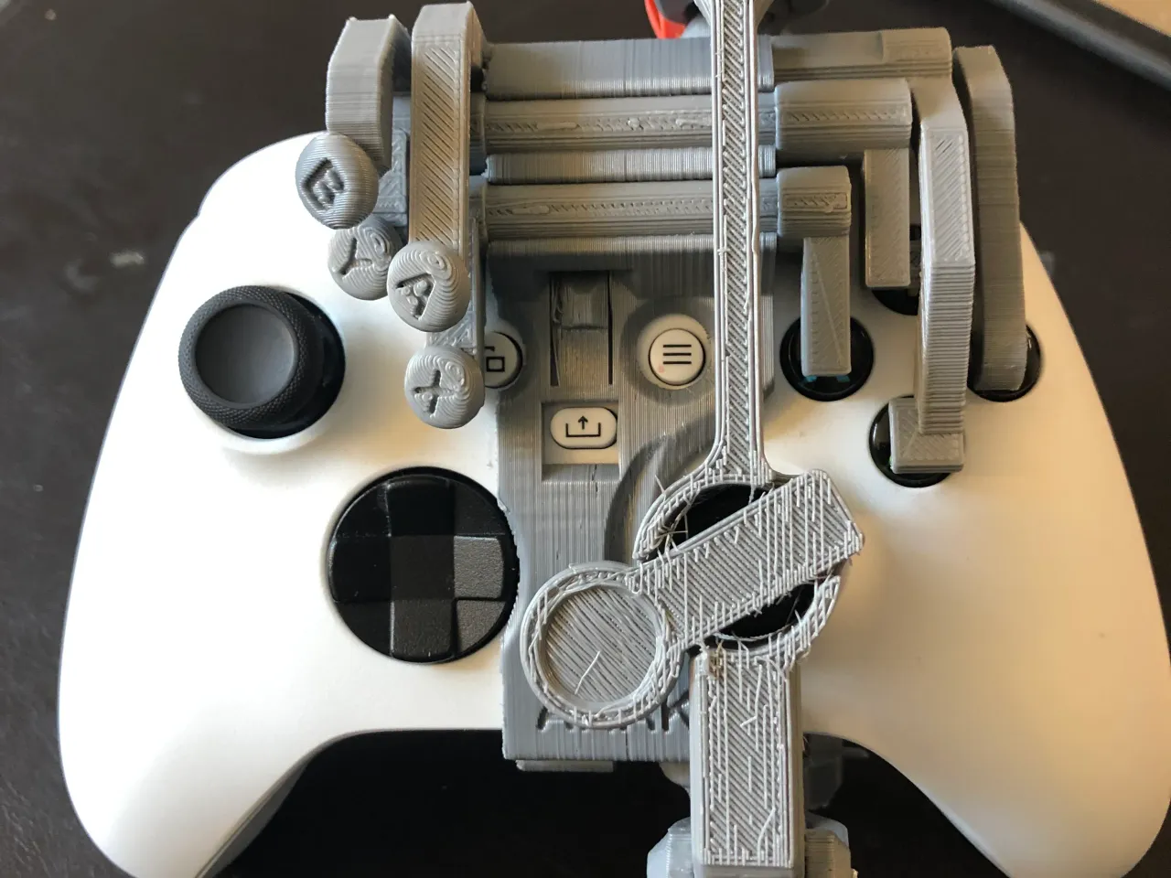

# 3D Printing Guide

Note that all components can be printed without supports as the designer built supports into the design where necessary.

## 3D Printing Summary

|  |  |  |  |  |
| --- | --- | --- | --- | --- |
| **Metrics** | **Right Handed Modification** | **Left Handed Modification** | **Button Decorations** | **Shoe** |
| Total Print Time (min) | 525 (8.75 hours) | 656 (10.9 hours) | 4 (0.07 hours) | 72 (1.2 hours) |
| Total Number of Components | 10 | 12 | 5 | 1 |
| Typical Total Mass (g) | 55 | 68 | <1 | 9 |
| Typical Number of Print Setups | 1 | 1 | 1 | 1 |

## 3D Printing Settings

|  |  |  |  |  |  |  |  |
| --- | --- | --- | --- | --- | --- | --- | --- |
| **Print File Name** | **Qty** | **Total Print Time (hr:min)** | **Mass (g)** | **Infill (%)** | **Support(Y/N)** | **Layer Height/ Nozzle Diameter(mm)** | **Notes (orientation, special settings, etc.)** |
| right handed xbox v1.stl | 1 | 8:45 | 55 | 20 | N | 0.2/0.4 |  |
| left-handed-xbox-Series X_S controller.stl | 1 | 10:56 | 68 | 20 | N | 0.2/0.4 |  |
| shoe.stl | 1 | 1:12 | 9 | 20 | N | 0.2/0.4 | * Optional print to replace leg strap * Can be printed in TPU if available |
| button decorations.stl | 1 | 0:04 | <1 | 20 | N | 0.2/0.4 | * Optional print |

## Post-Processing

Remove any print helpers and built-in supports on the components.

## Examples of Quality Prints

The following pictures show examples of quality prints for each component required for the controller modifications.

## Right Hand Modification

**Trigger Pusher**

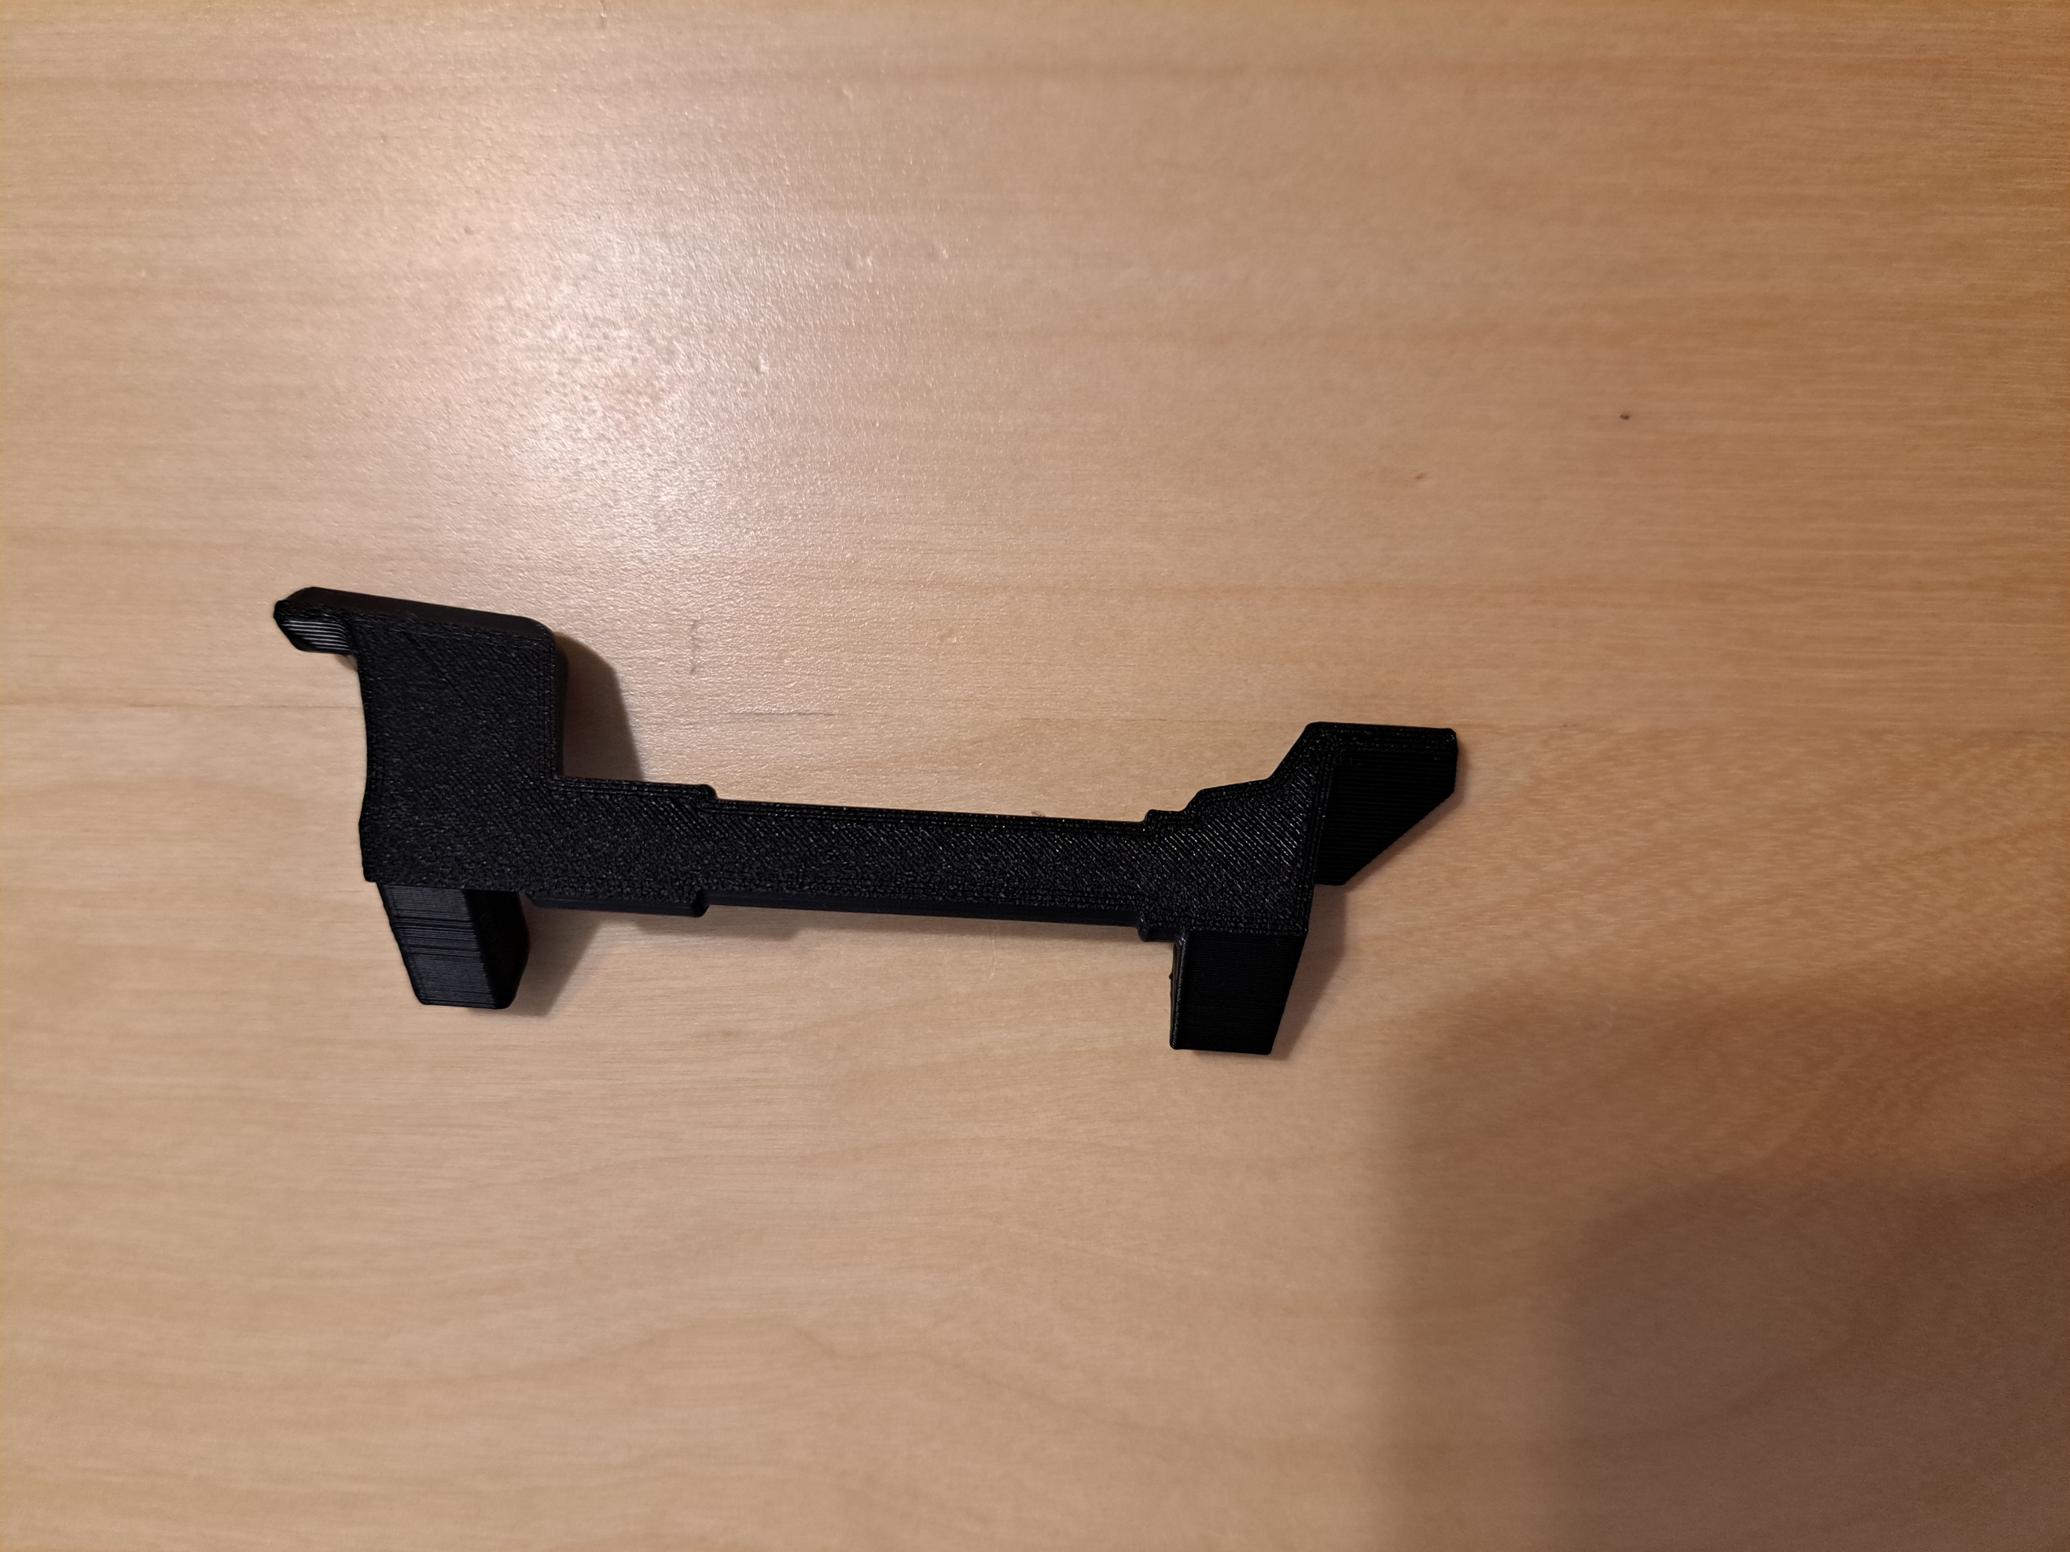

**D-Pad Pusher**

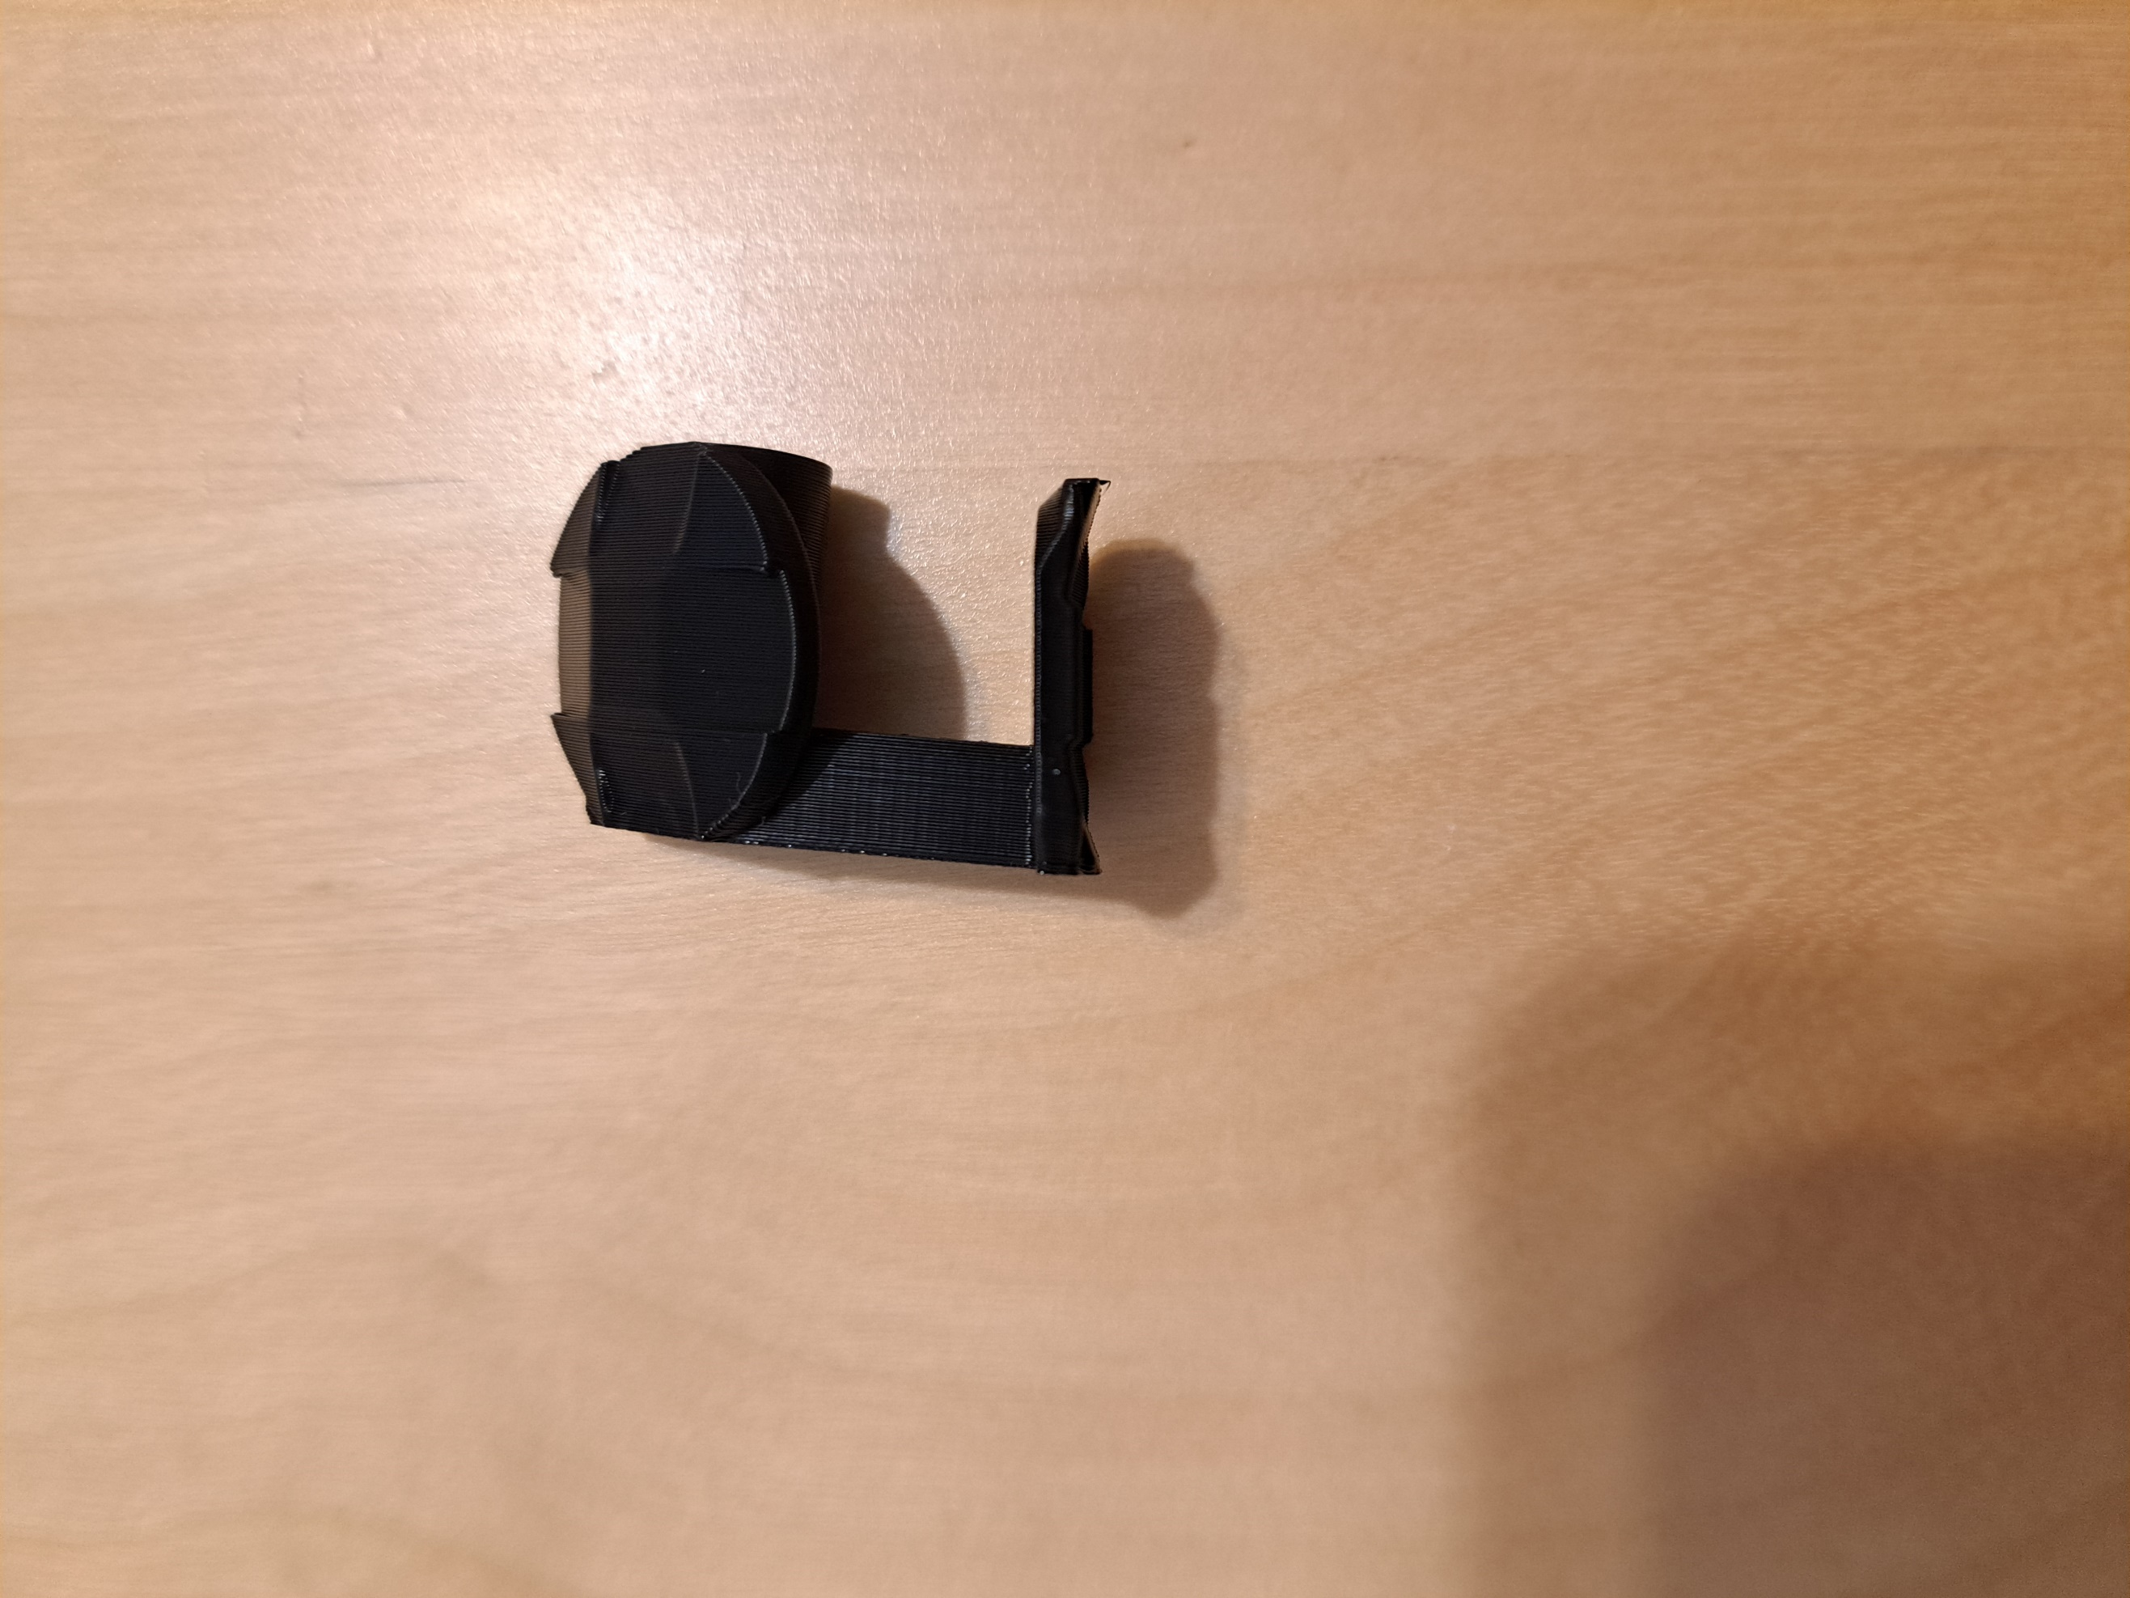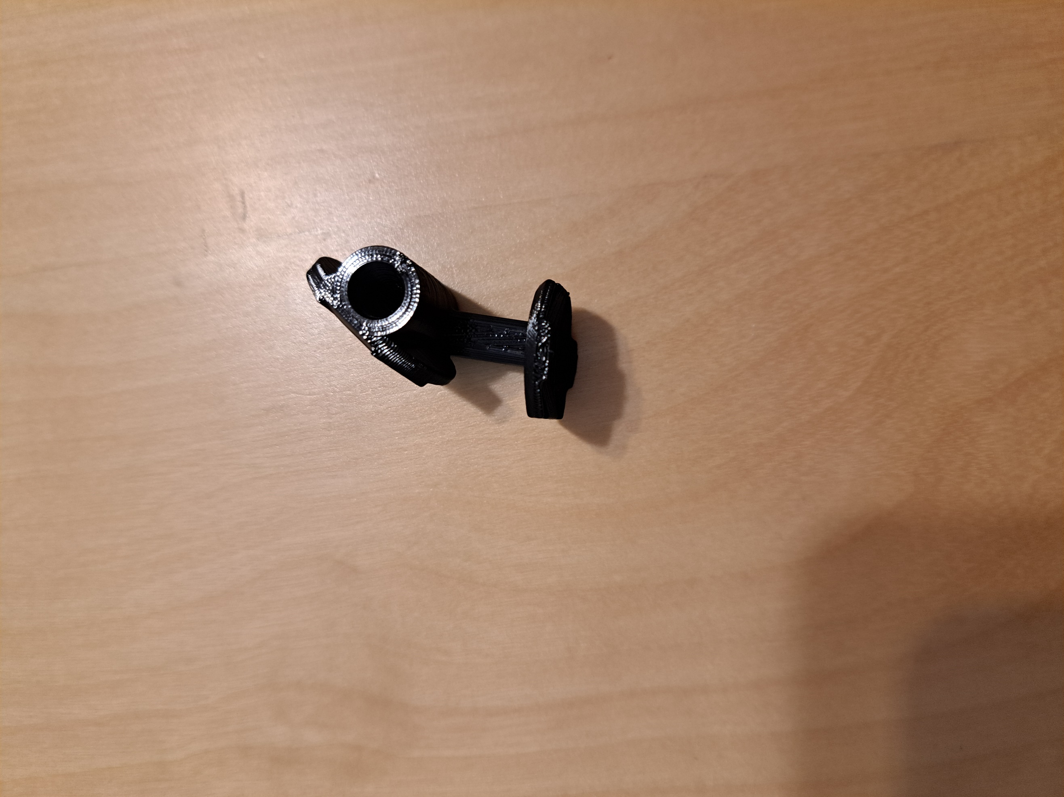

**Leg Strap/Shoe holder**

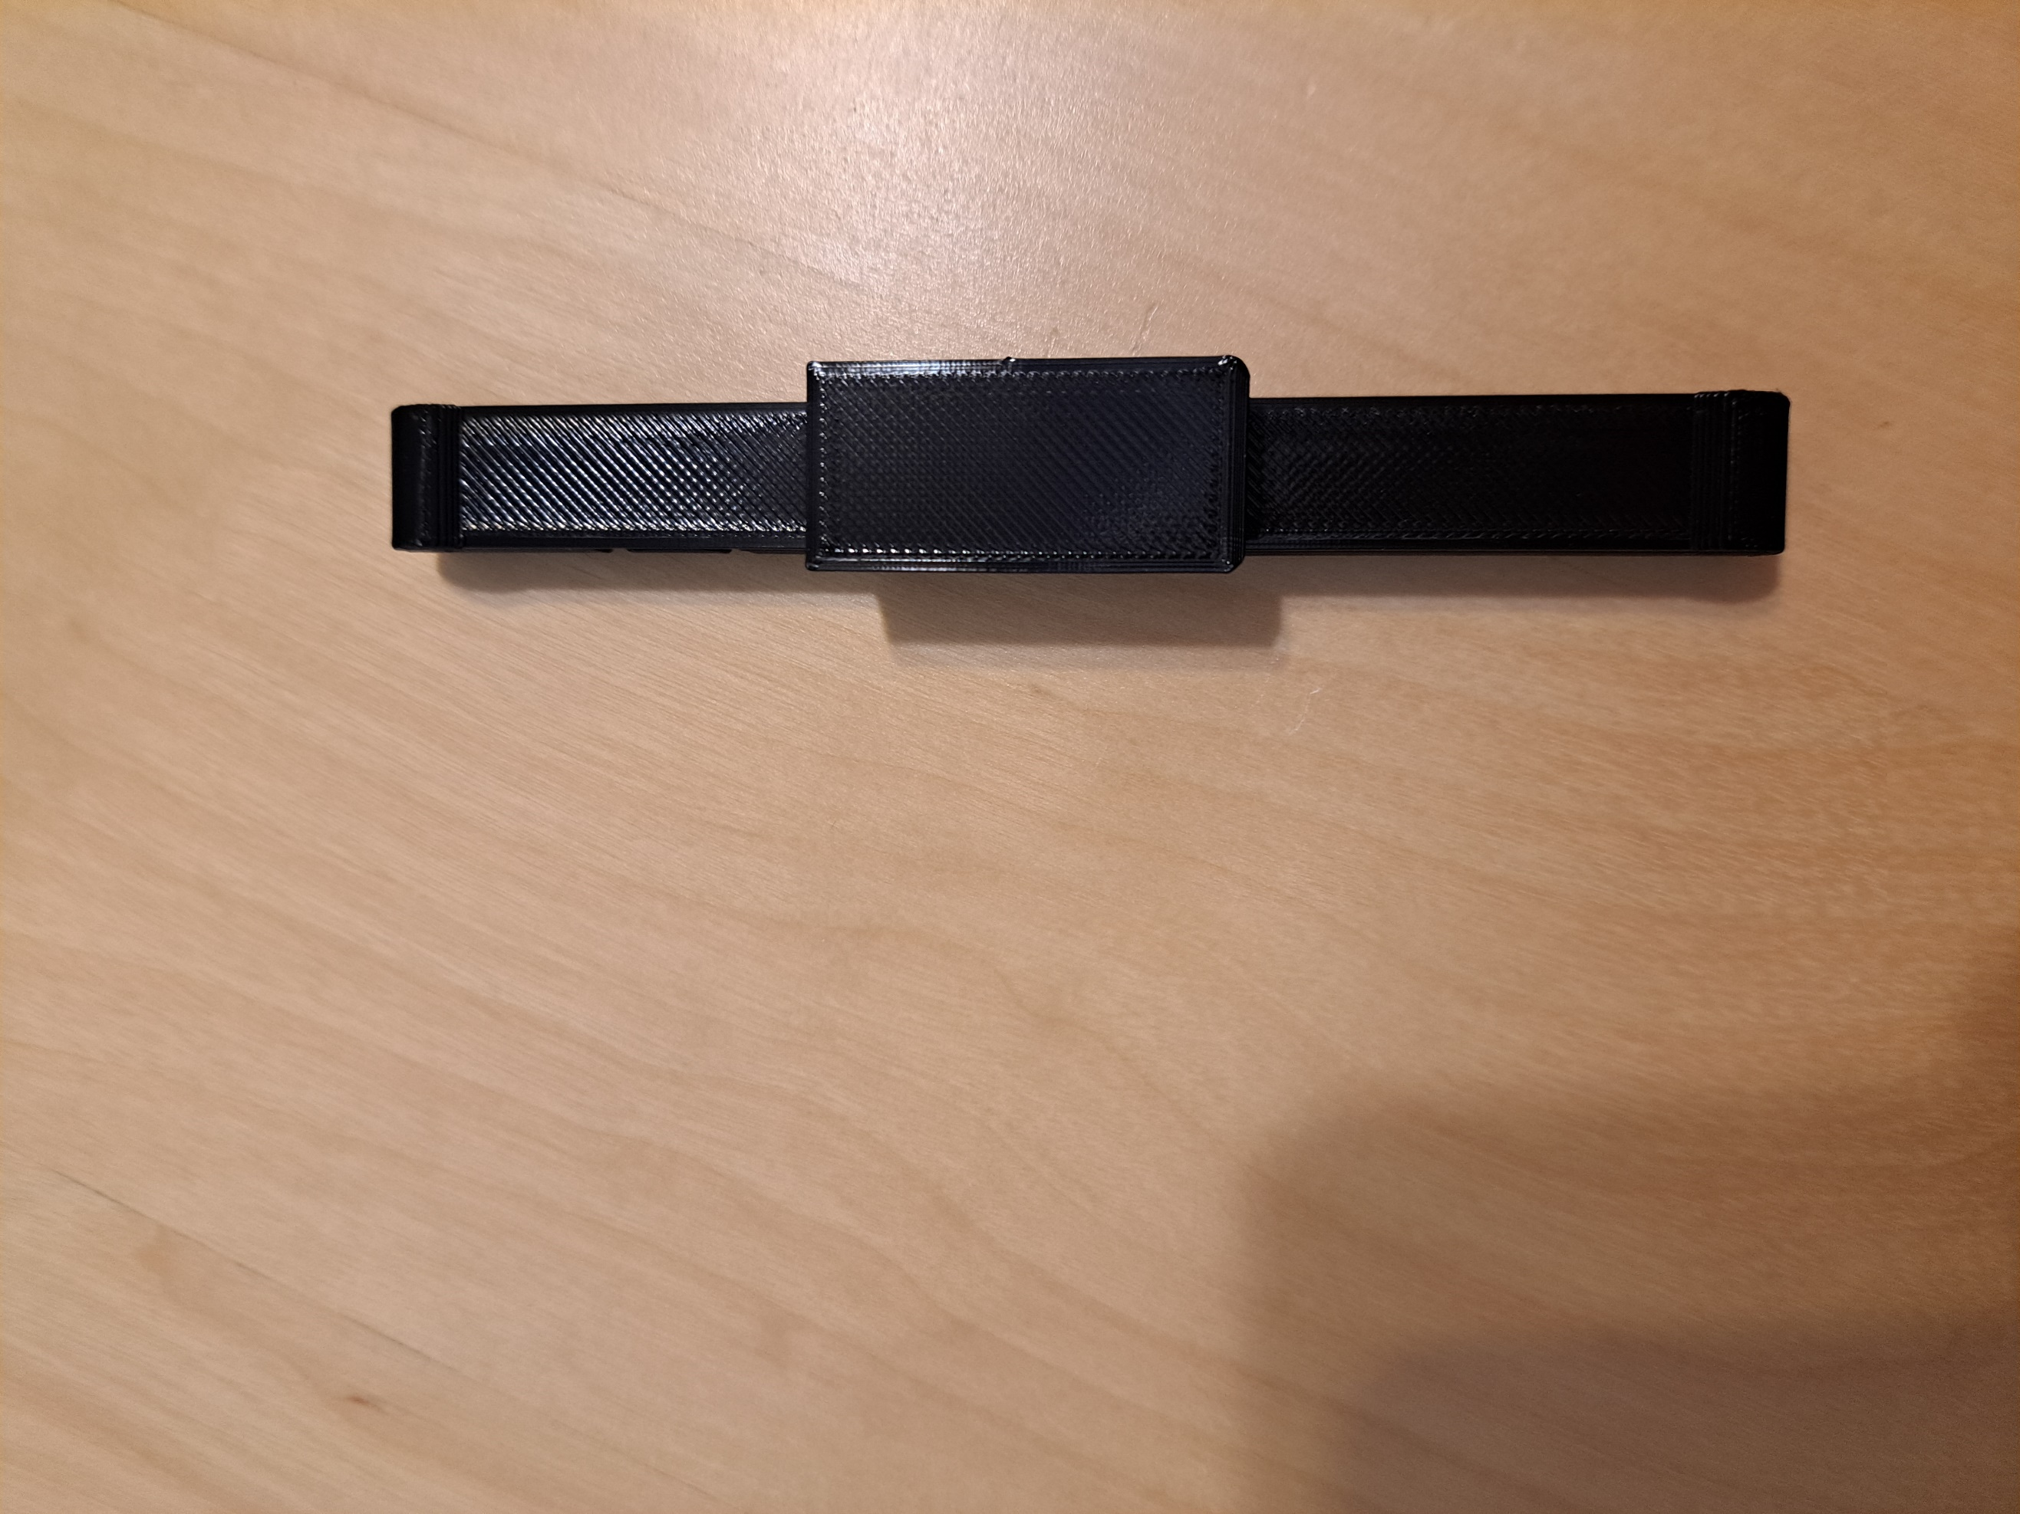

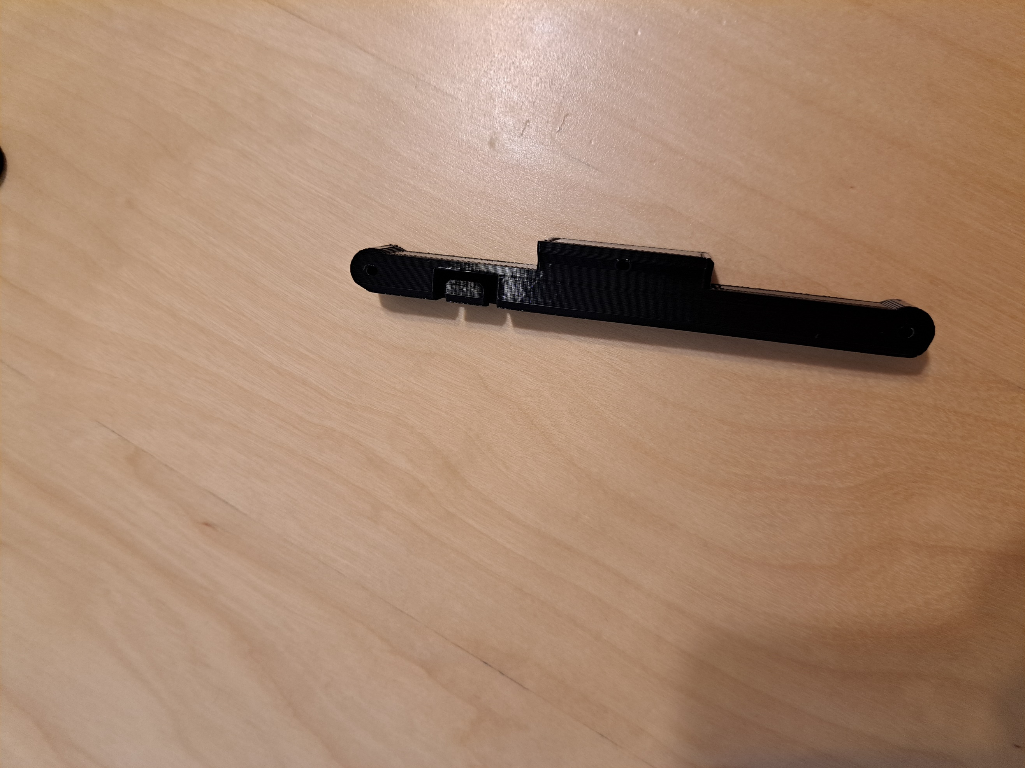

**Linkage Pieces**

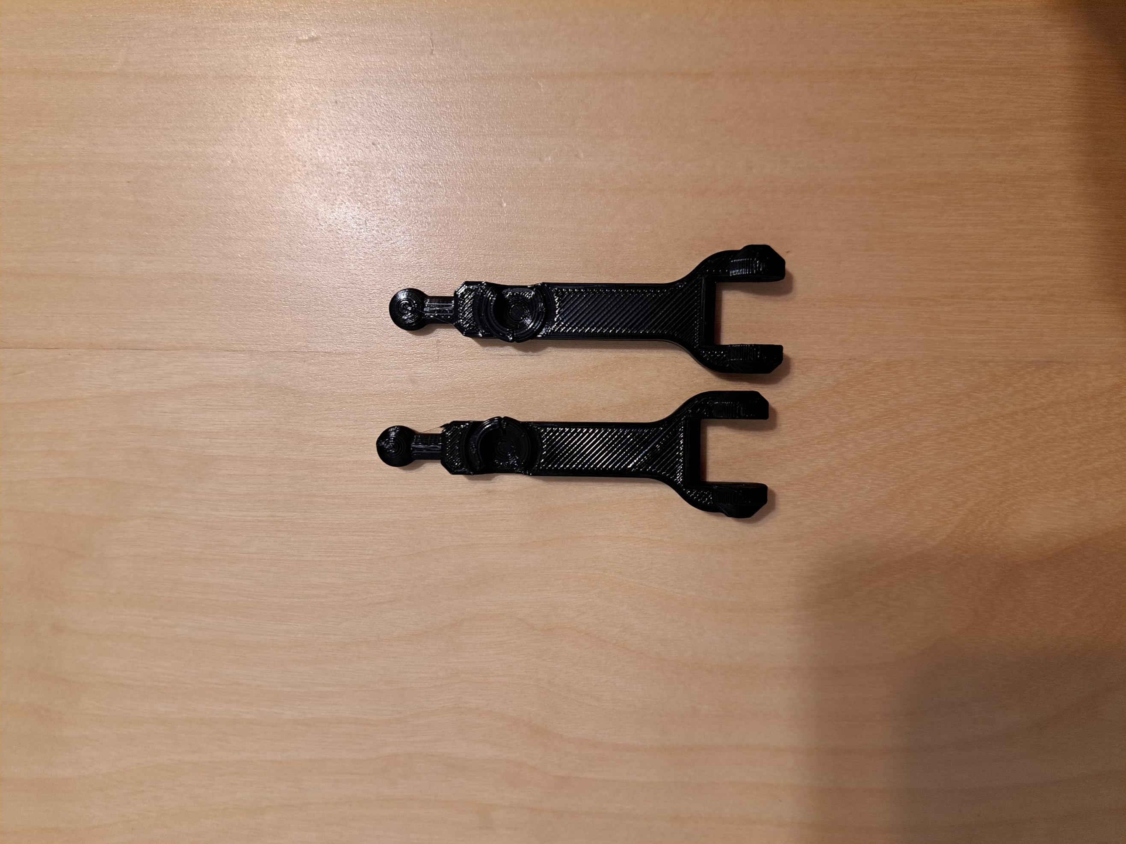

**Thumb Stick Mover**

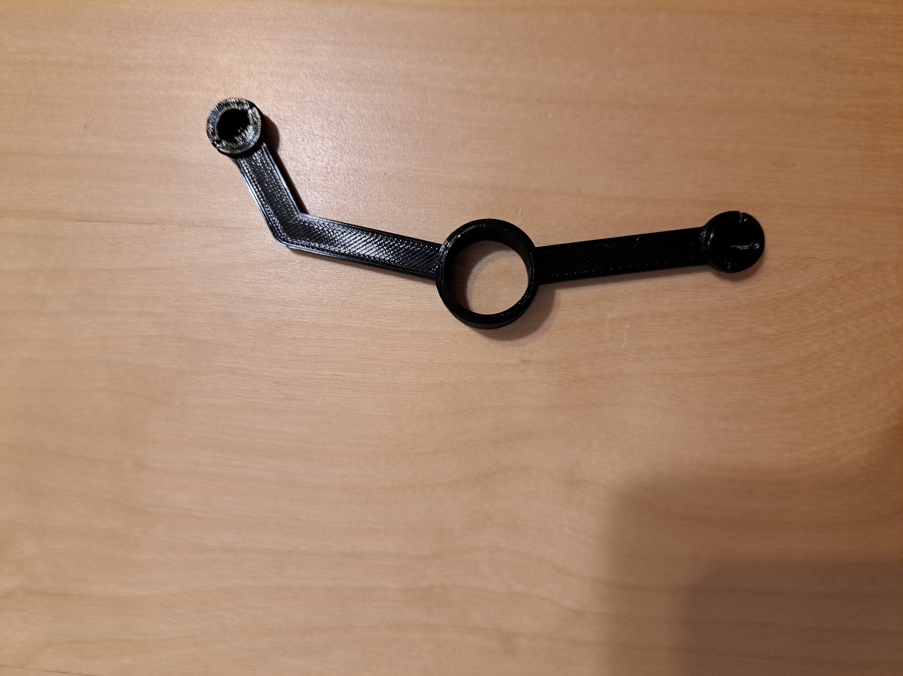

**Mount**

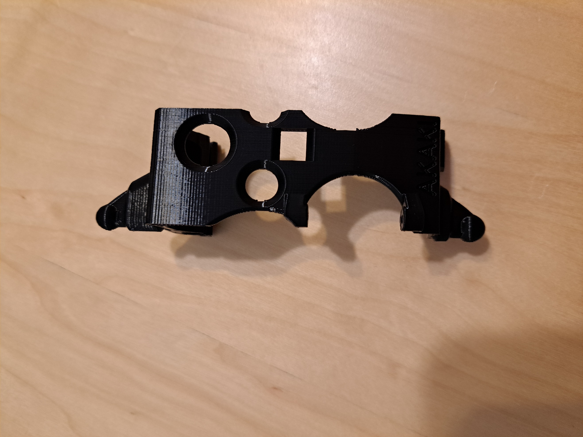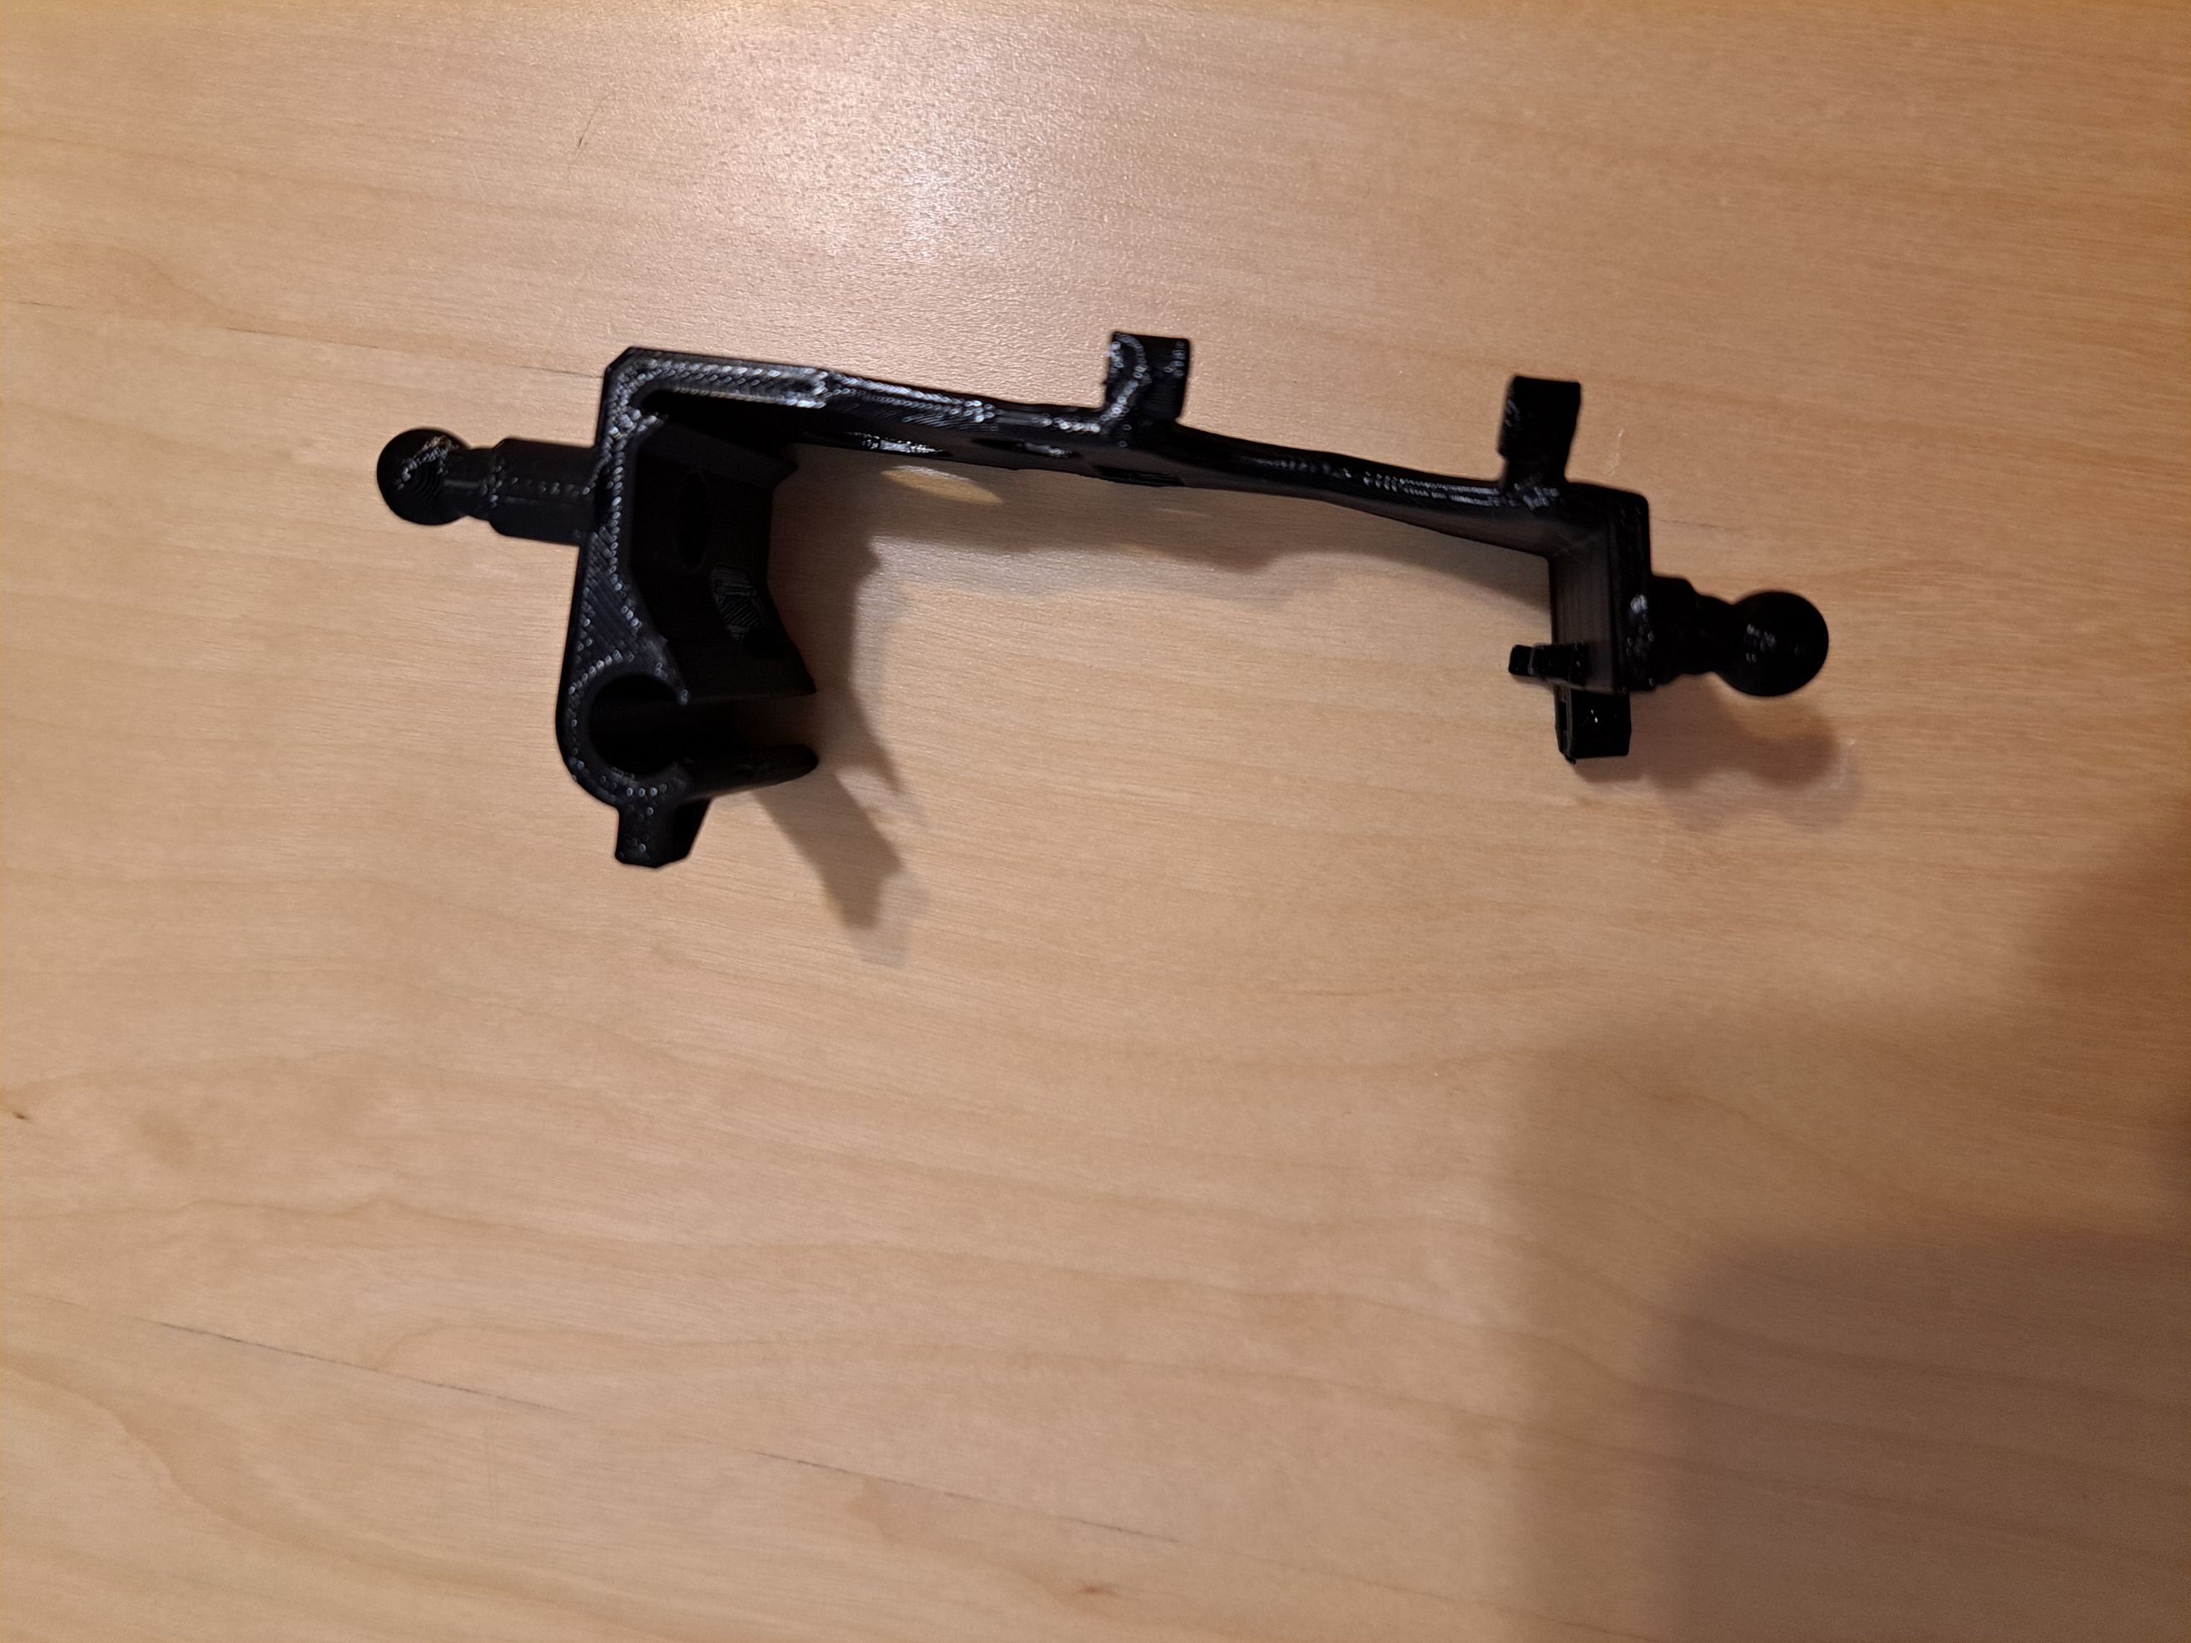

**Leg Strap Attachment**

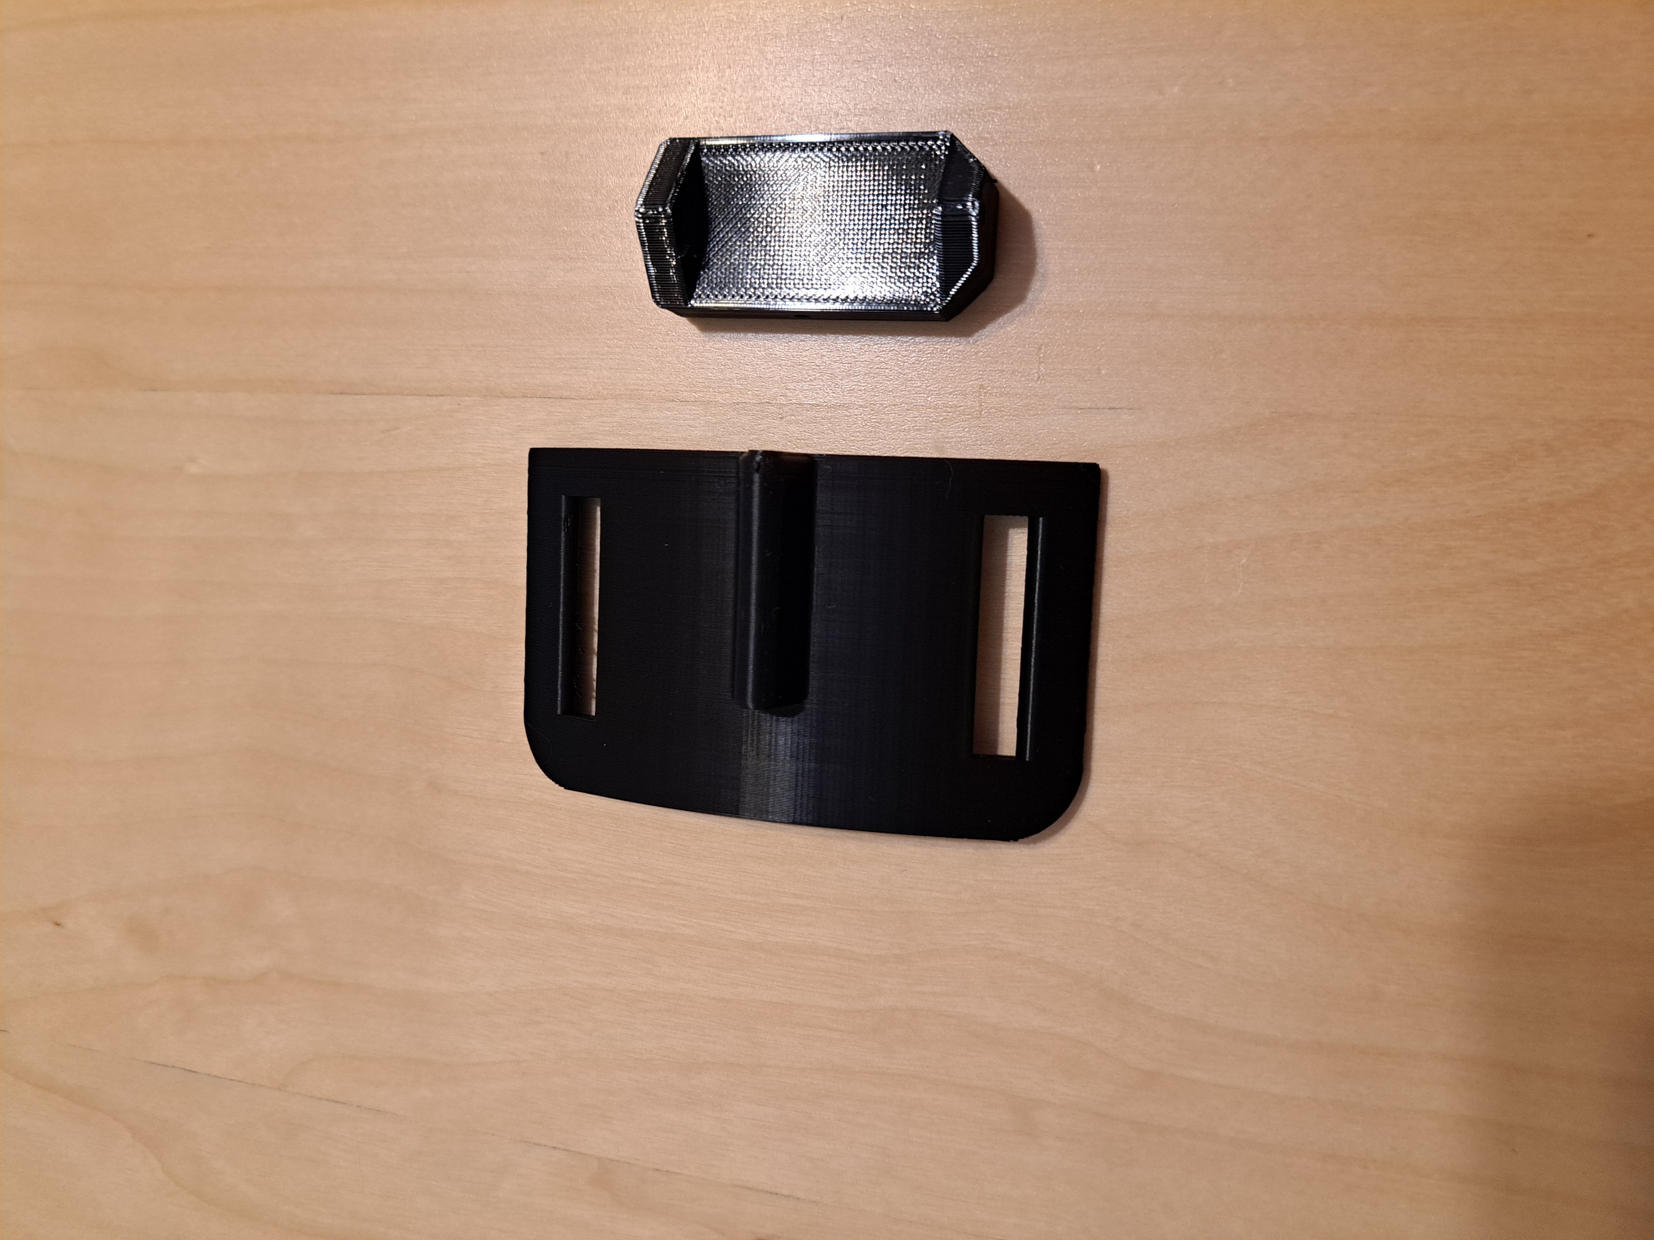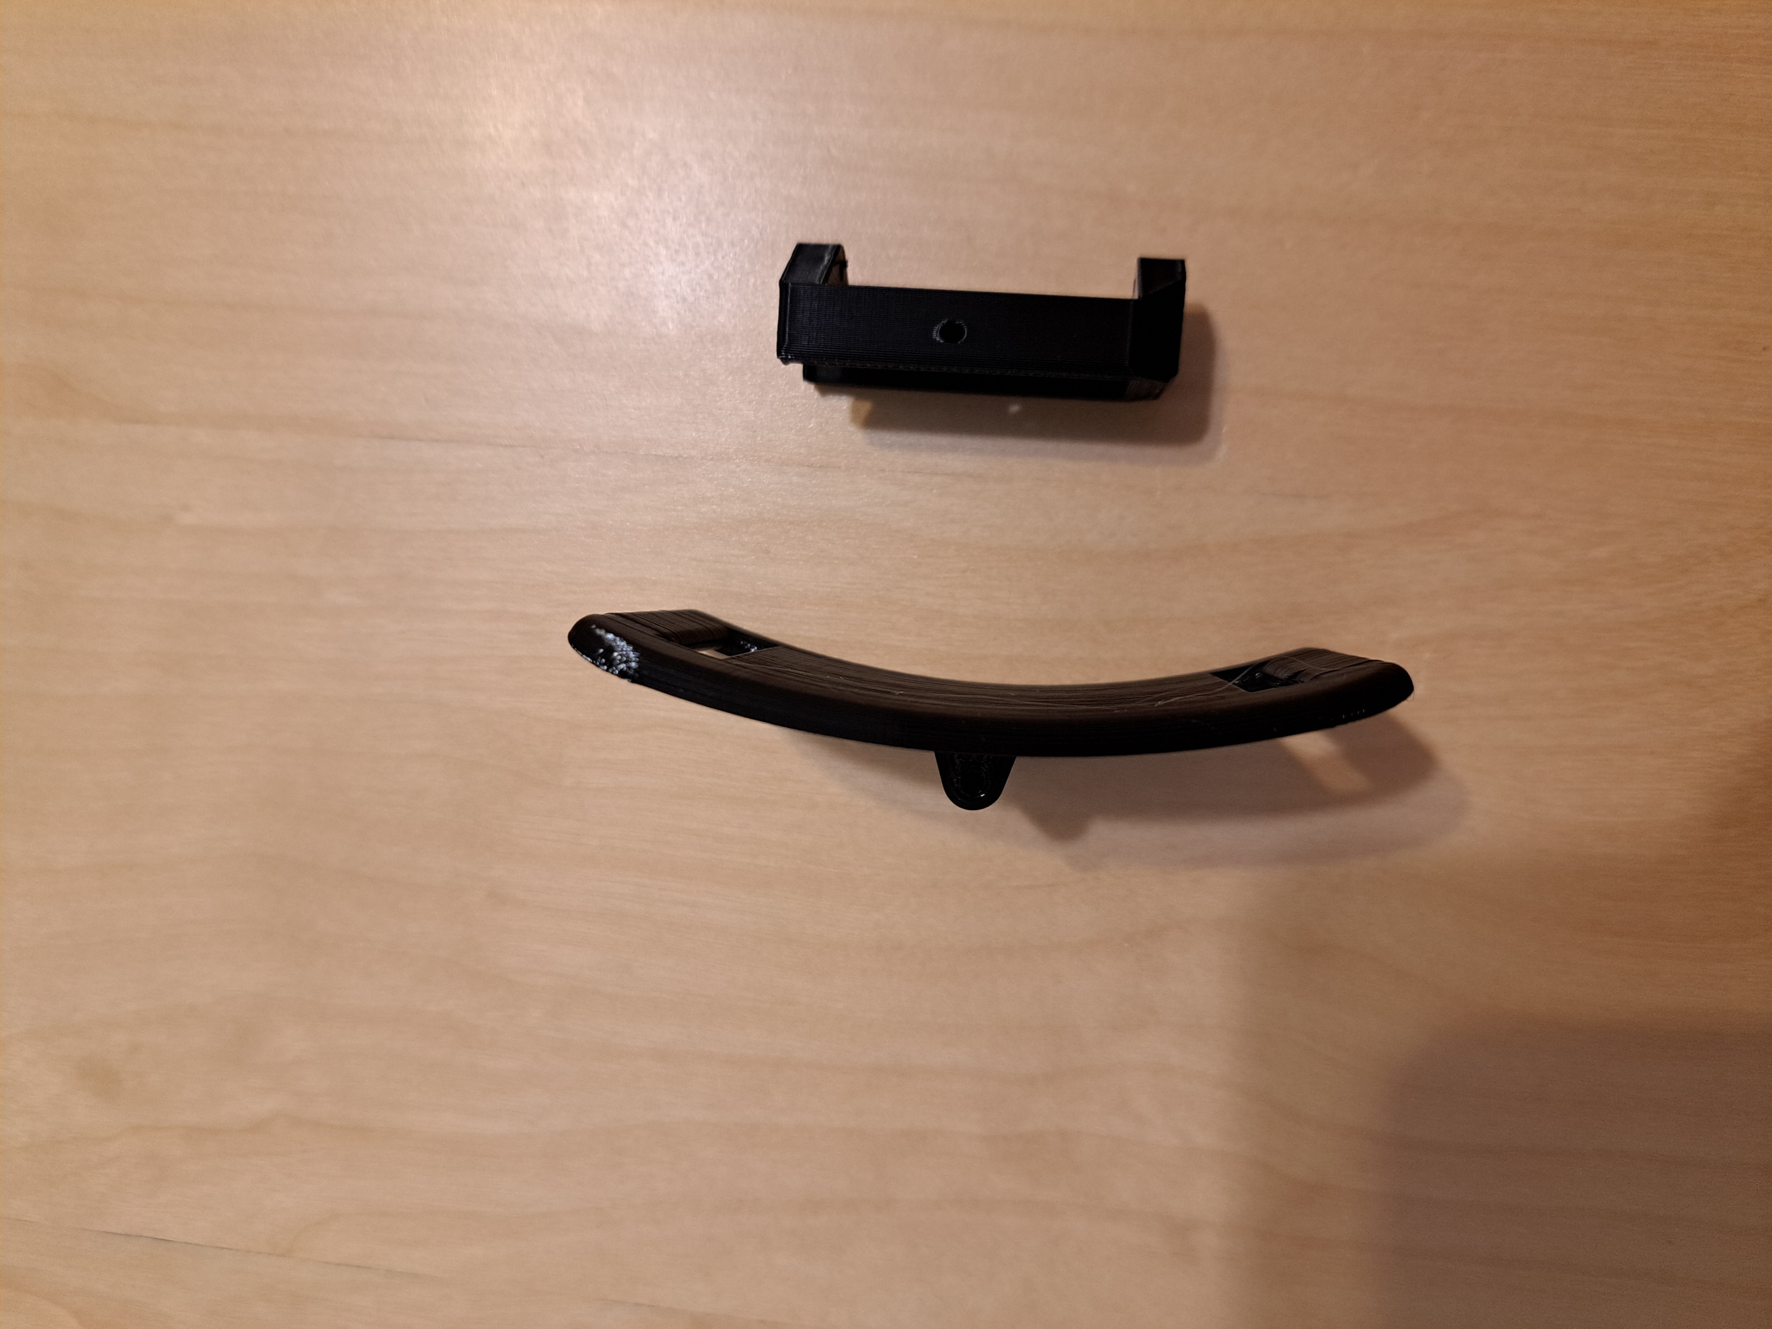

**Shoe**

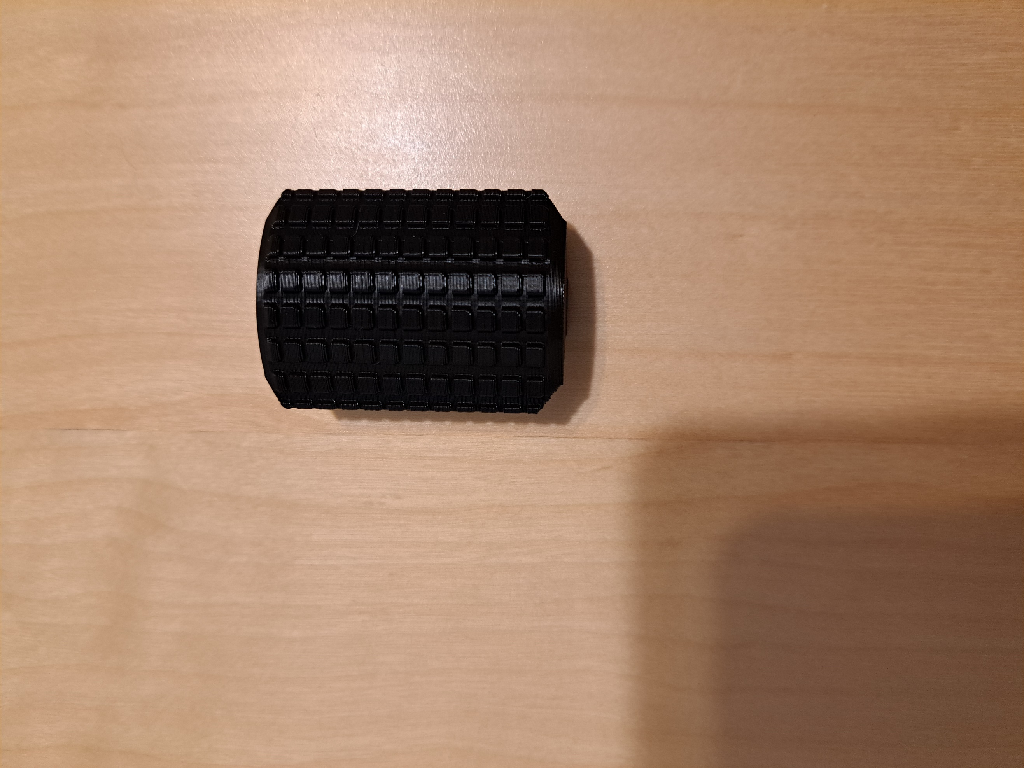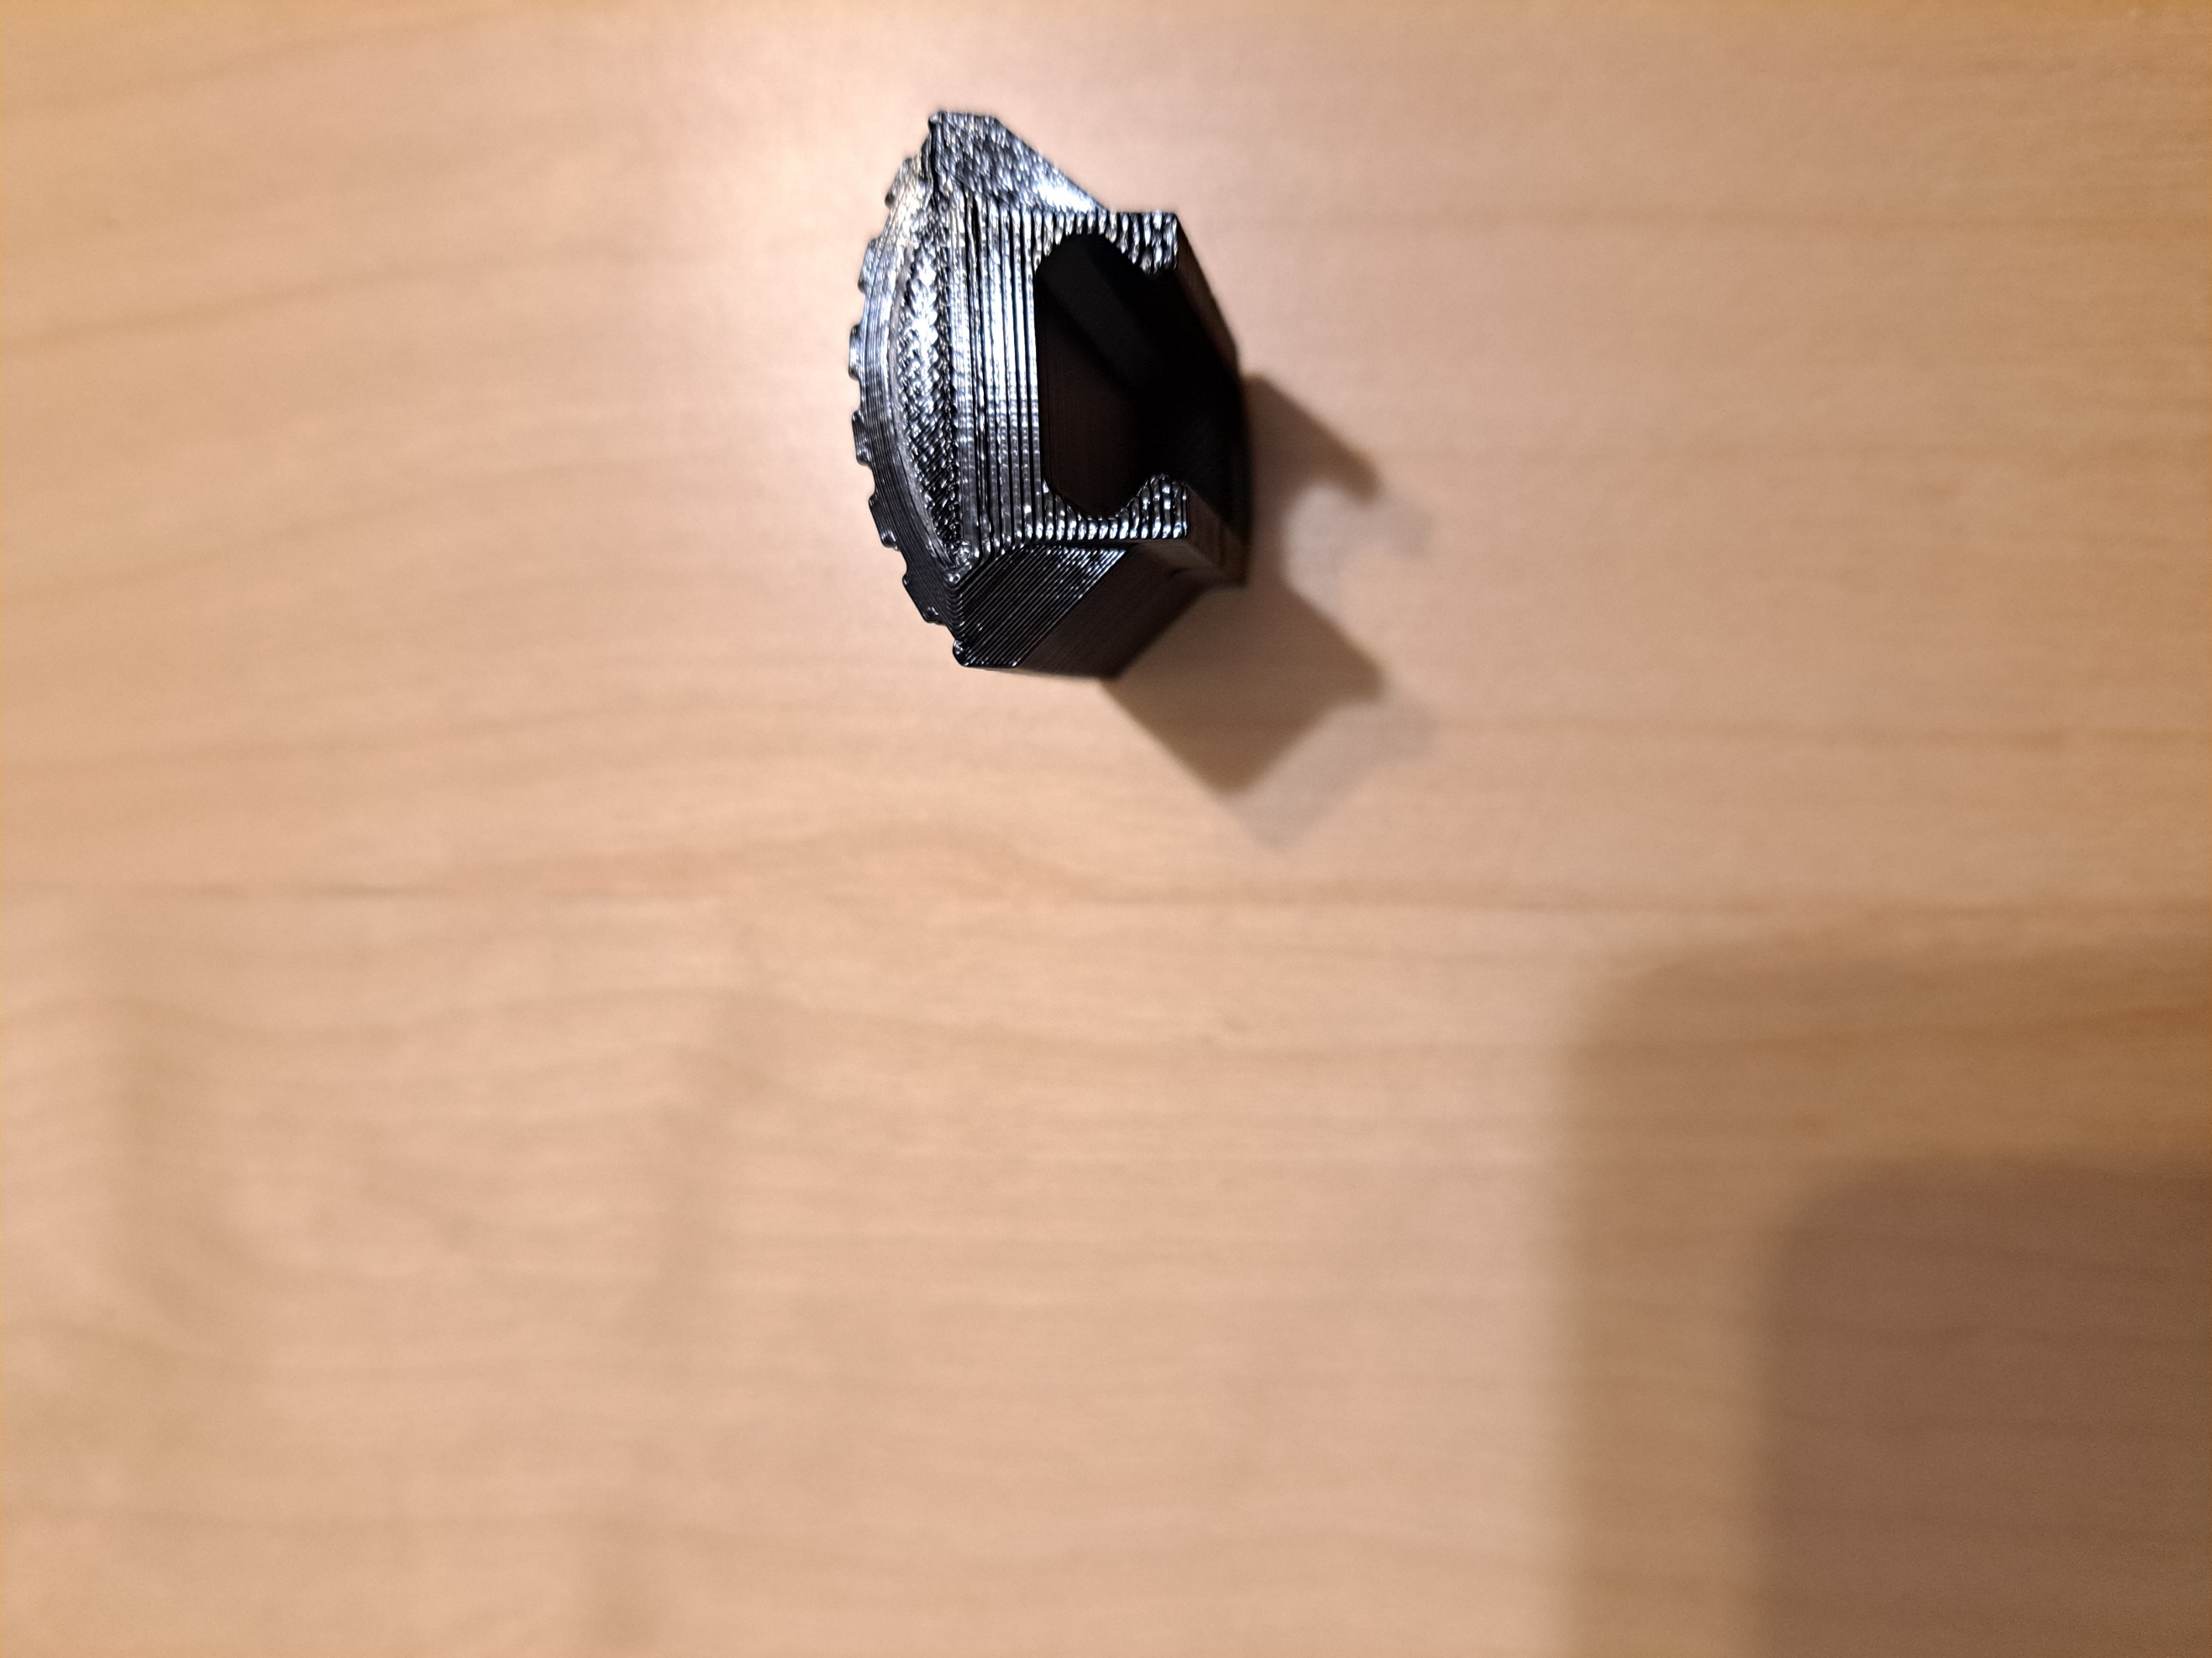

**Button Decorations**

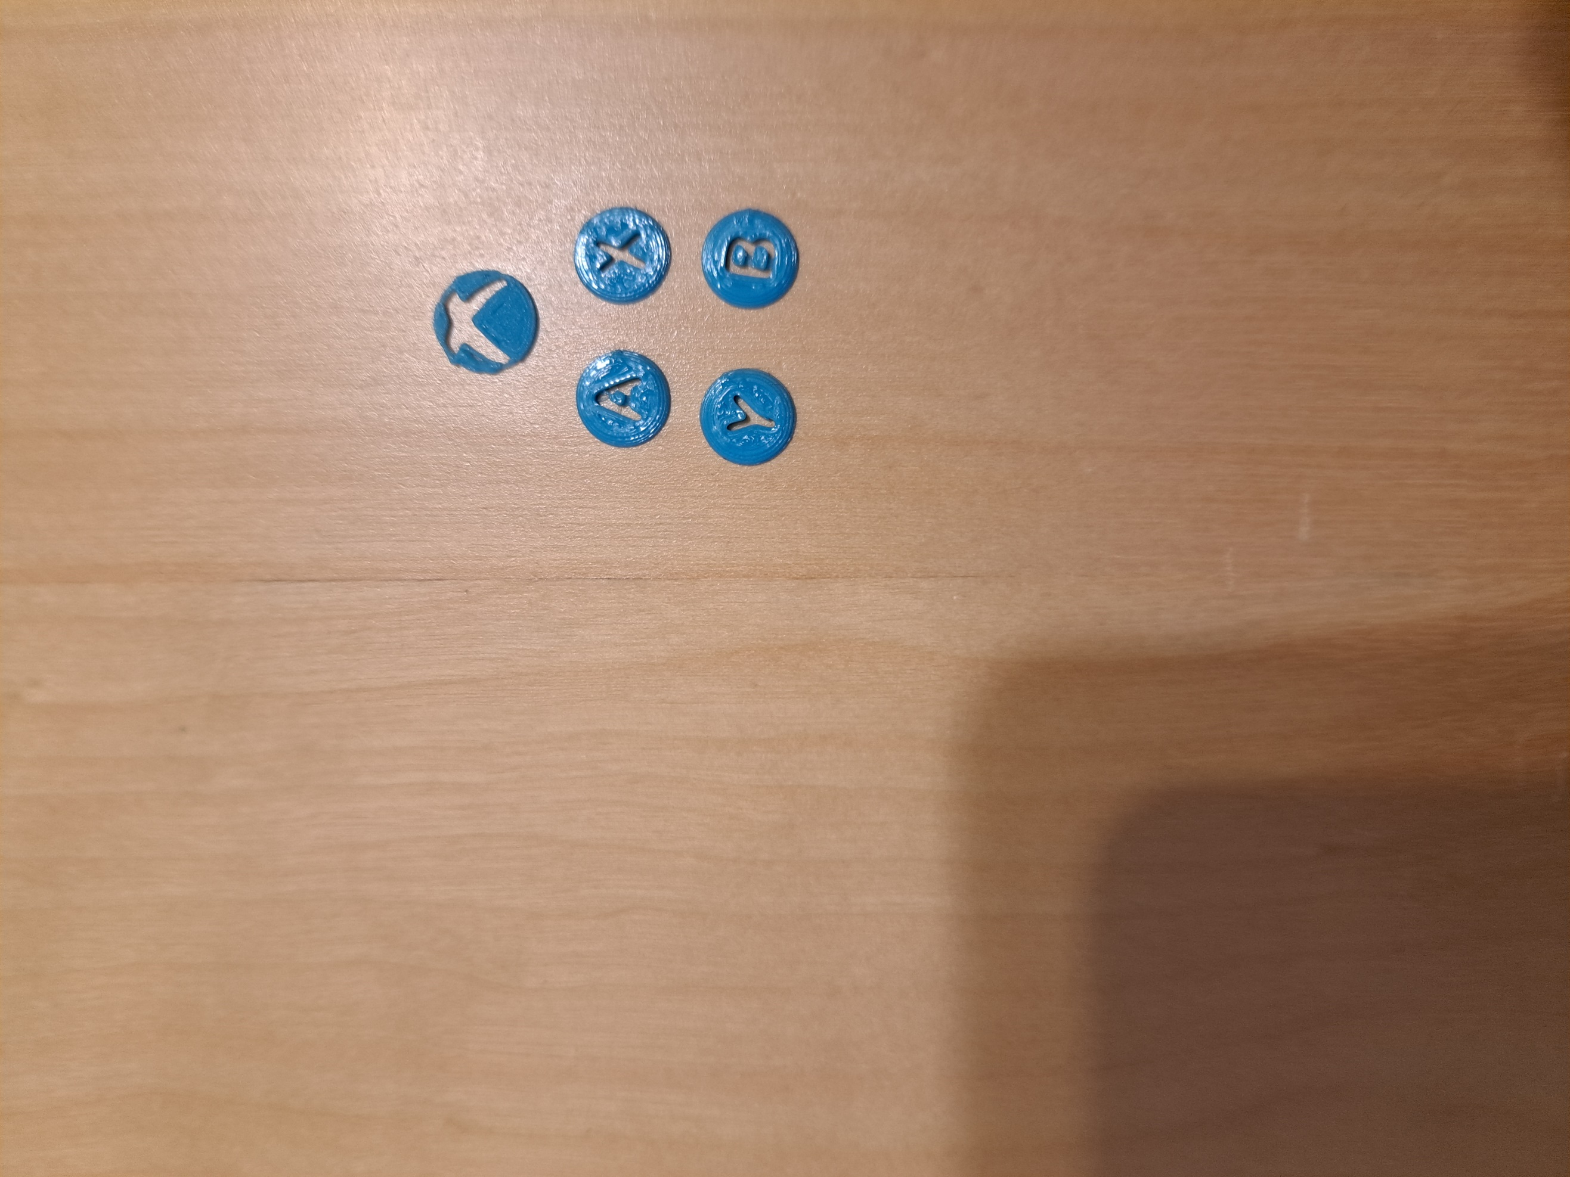

## Left Handed Modification

The left handed modification also includes the trigger pusher, leg strap/shoe holder, leg strap attachment/shoe, and optional button decorations. These parts are the same as those for the right handed modification.

**B Button Pusher**

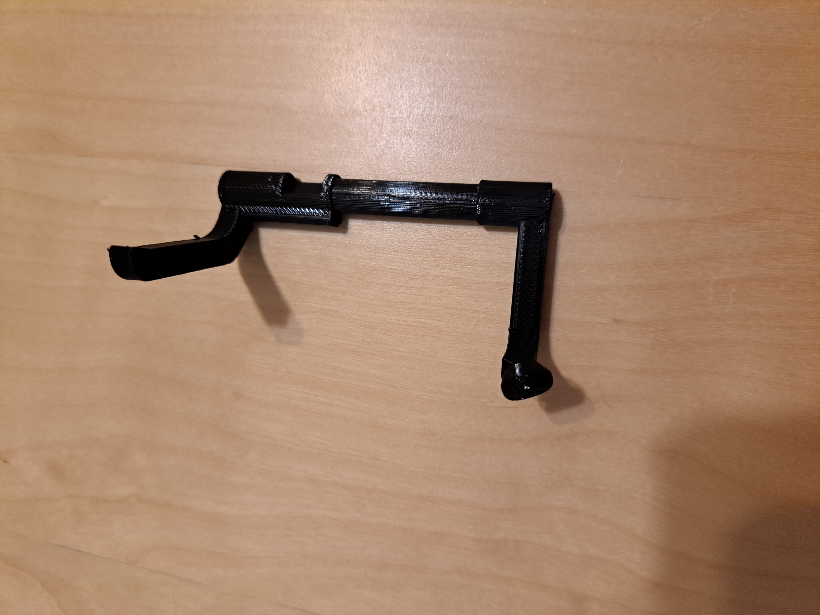

**A Button Pusher**

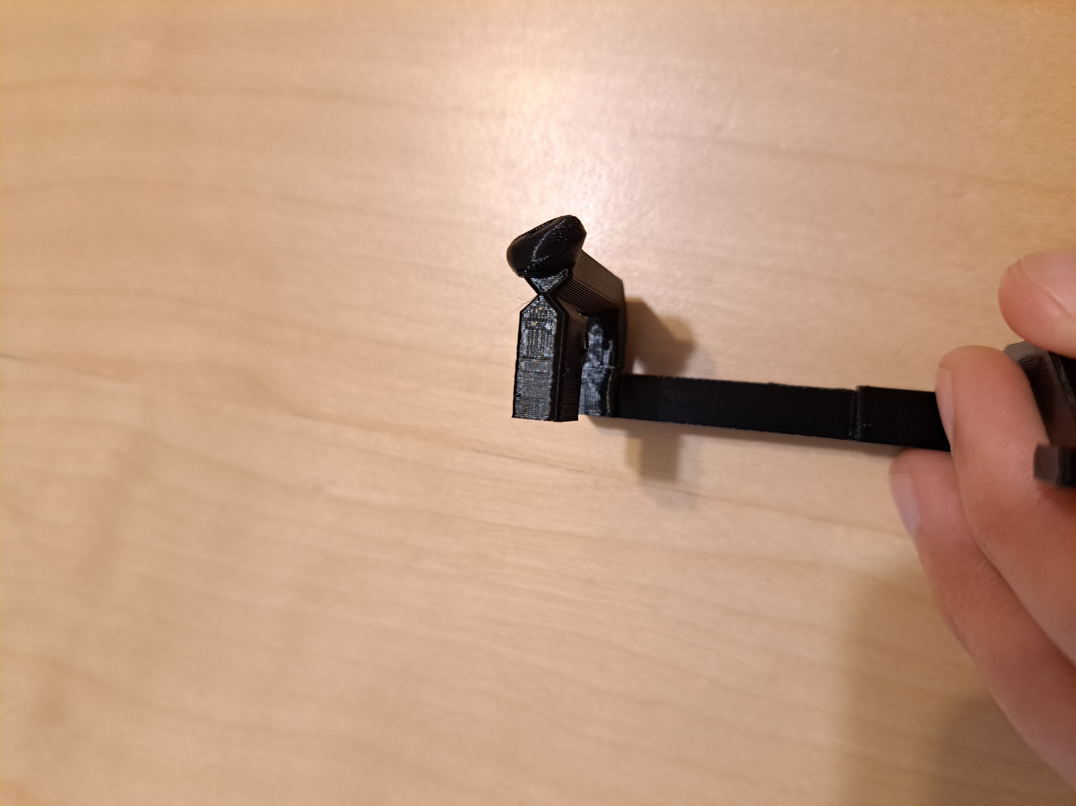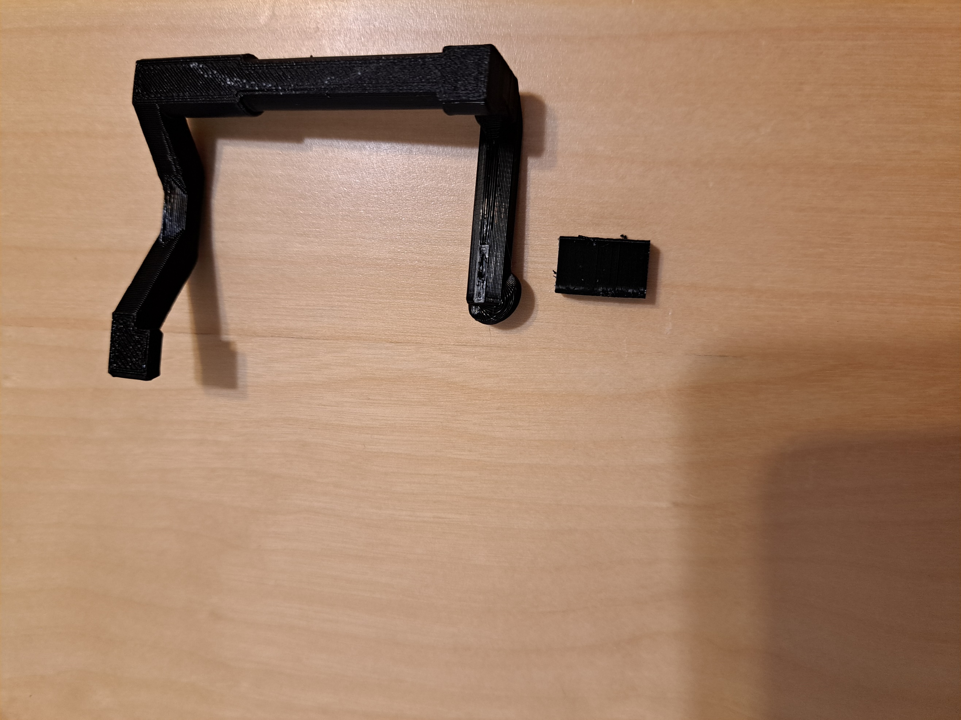

The A Button pusher has a built-in support, which is circled in the first picture. The support must be snapped off, and it comes off easily. The break should be clean, as seen in the last picture above.

**Y Button Pusher**

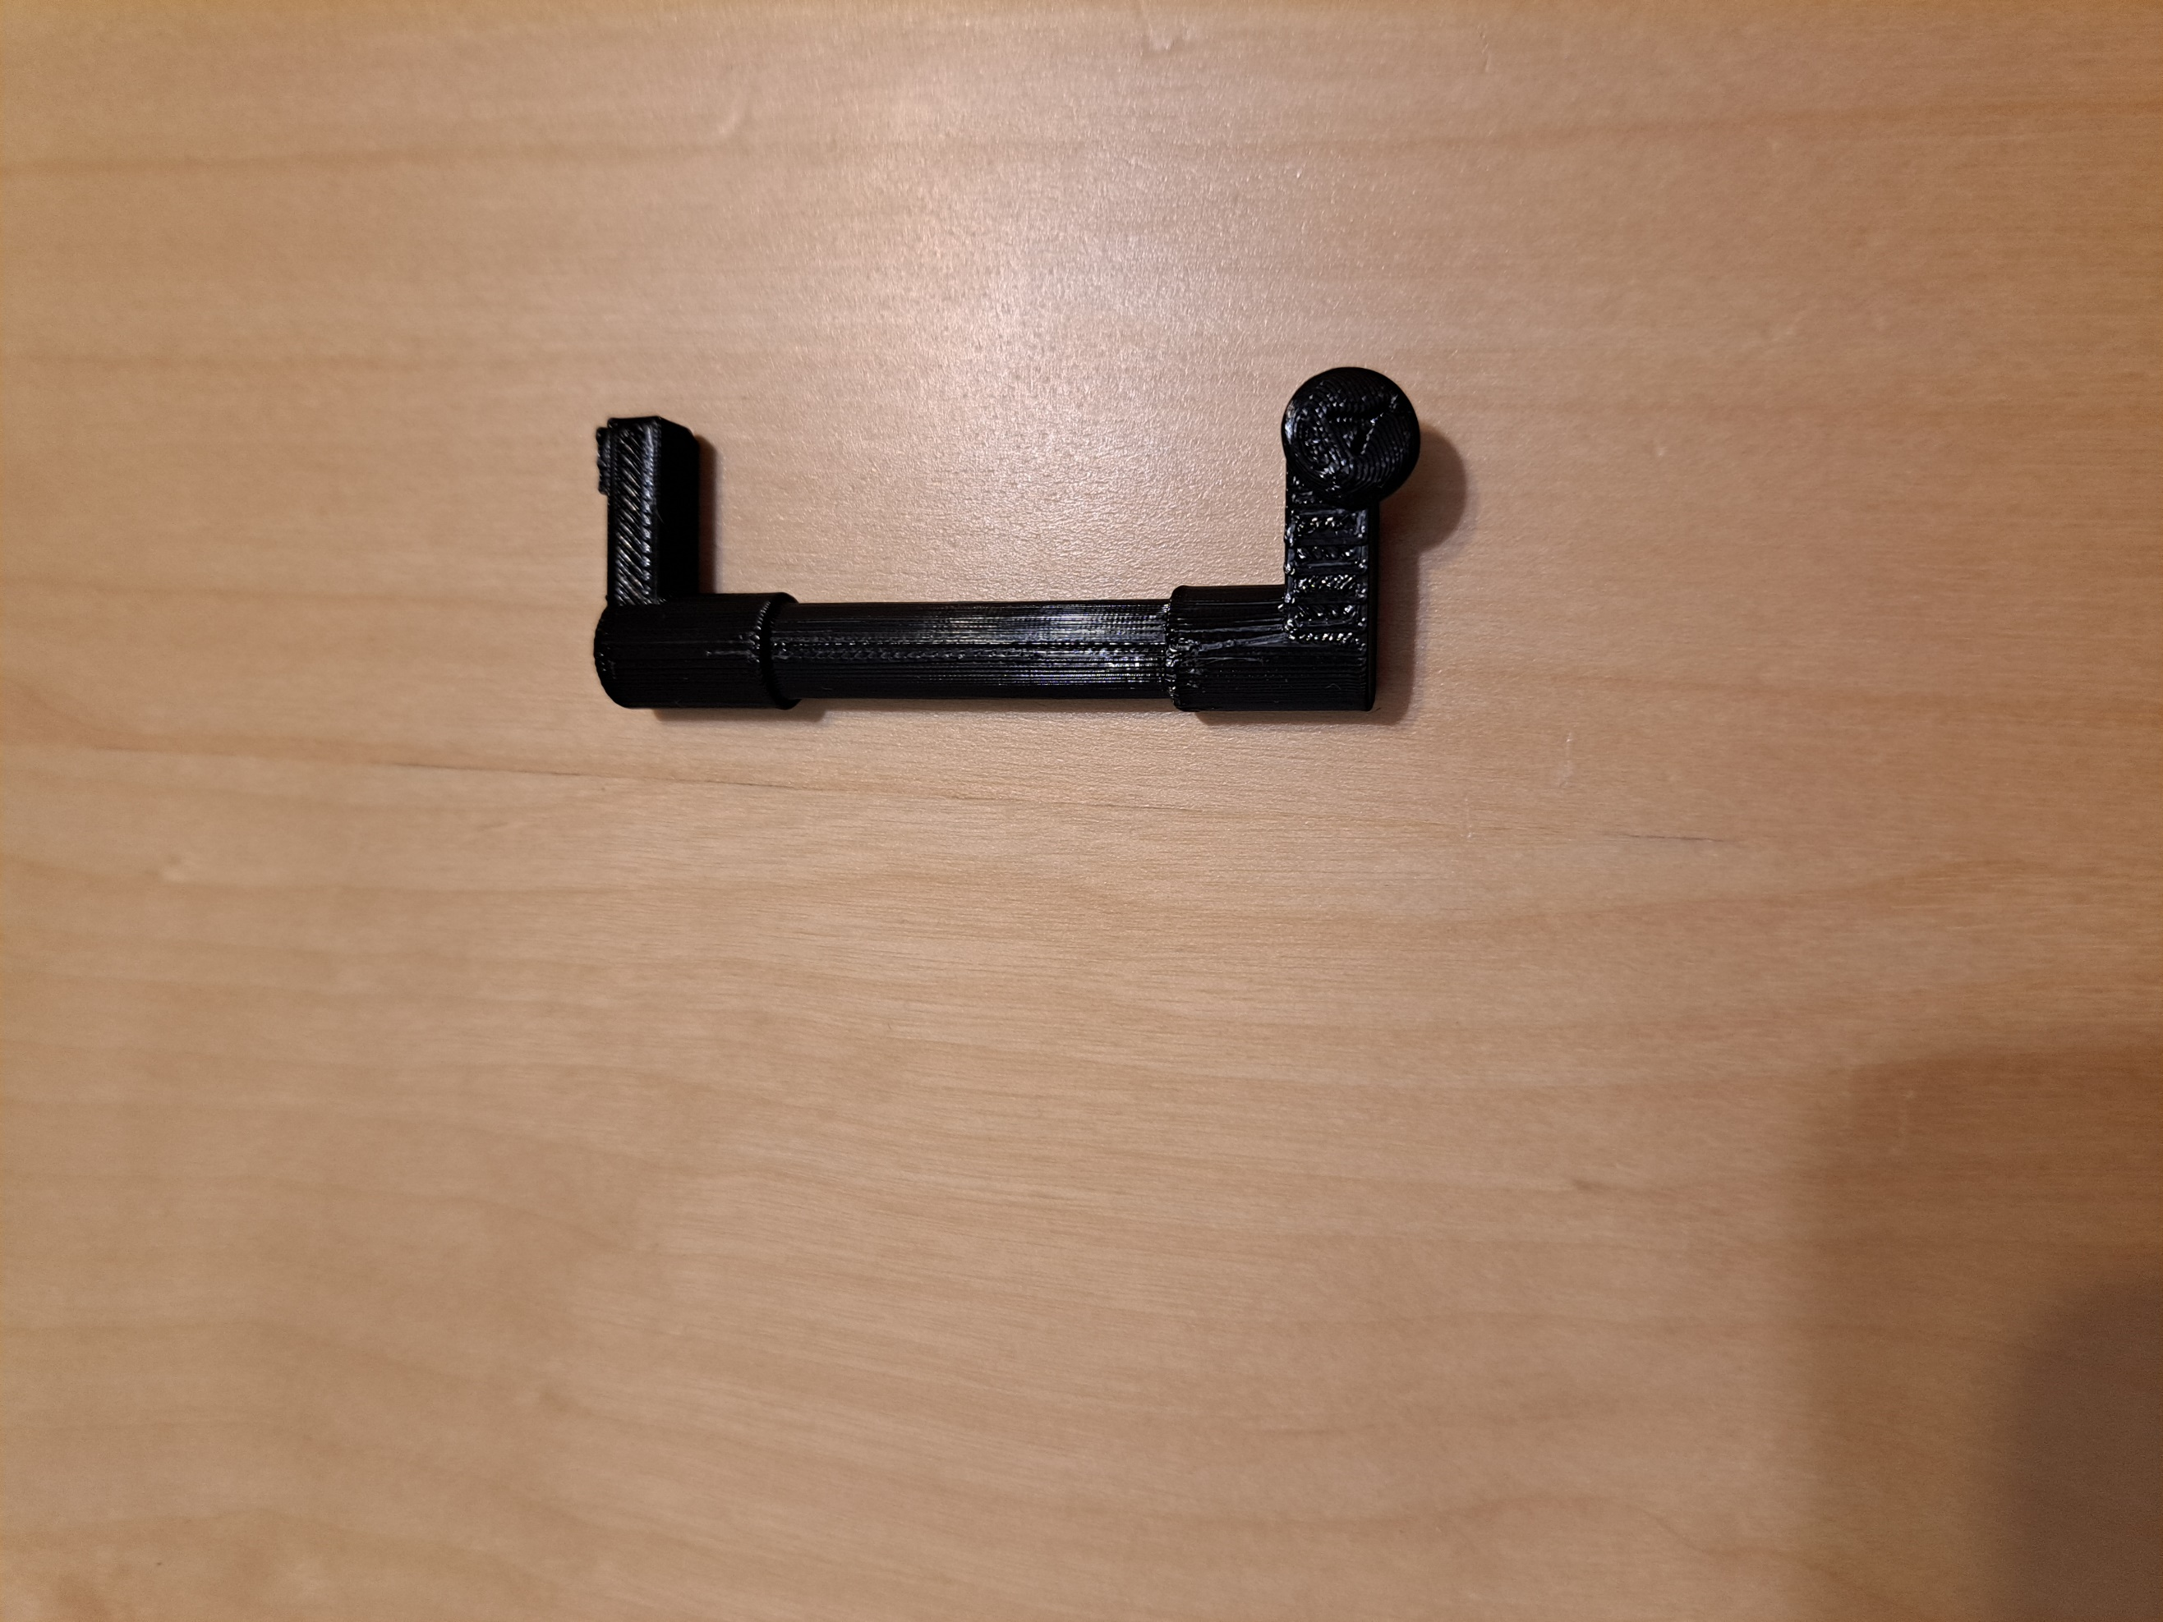

**X Button Pusher**

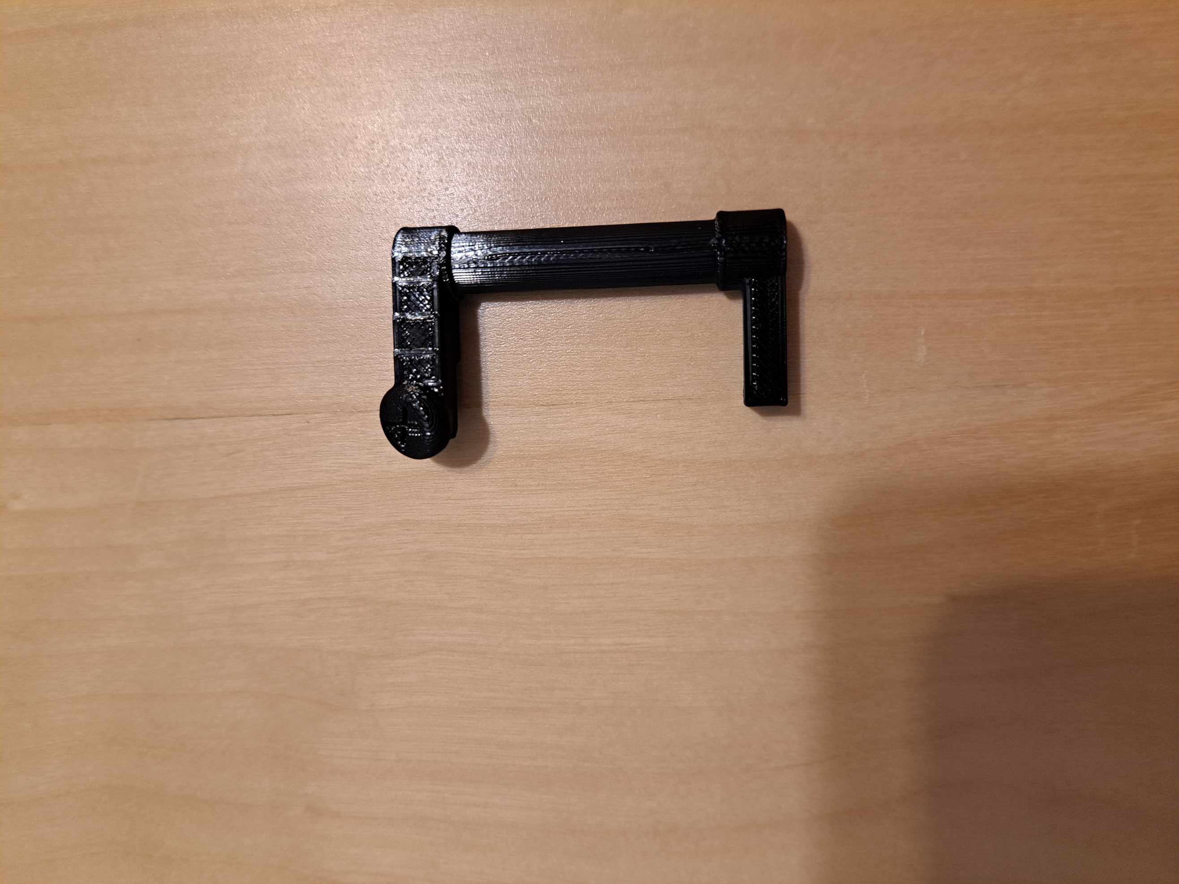

**Linkage Pieces**

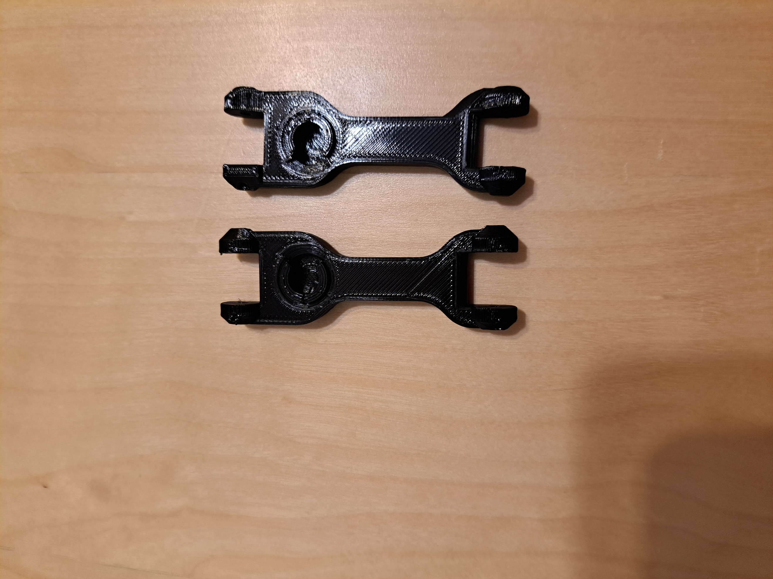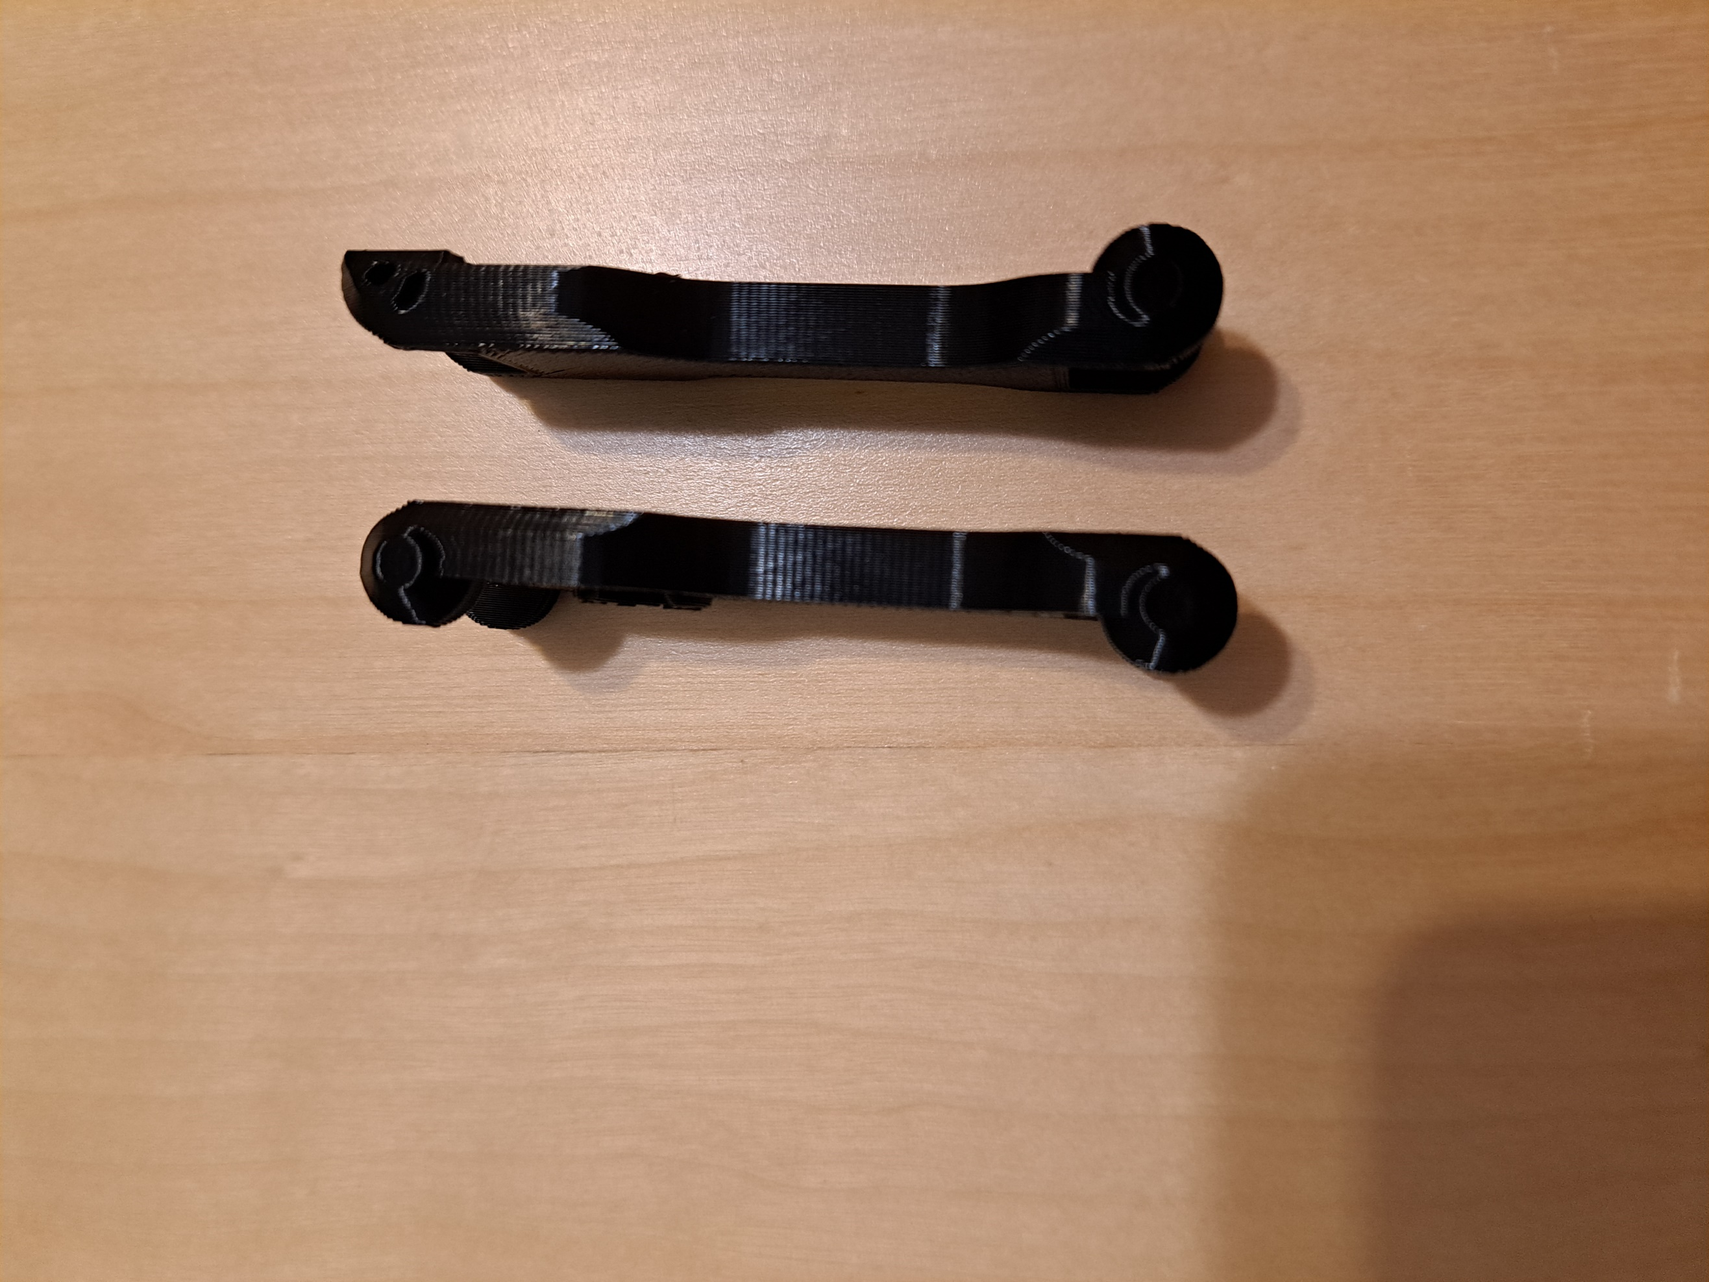

**Thumb Stick Mover**

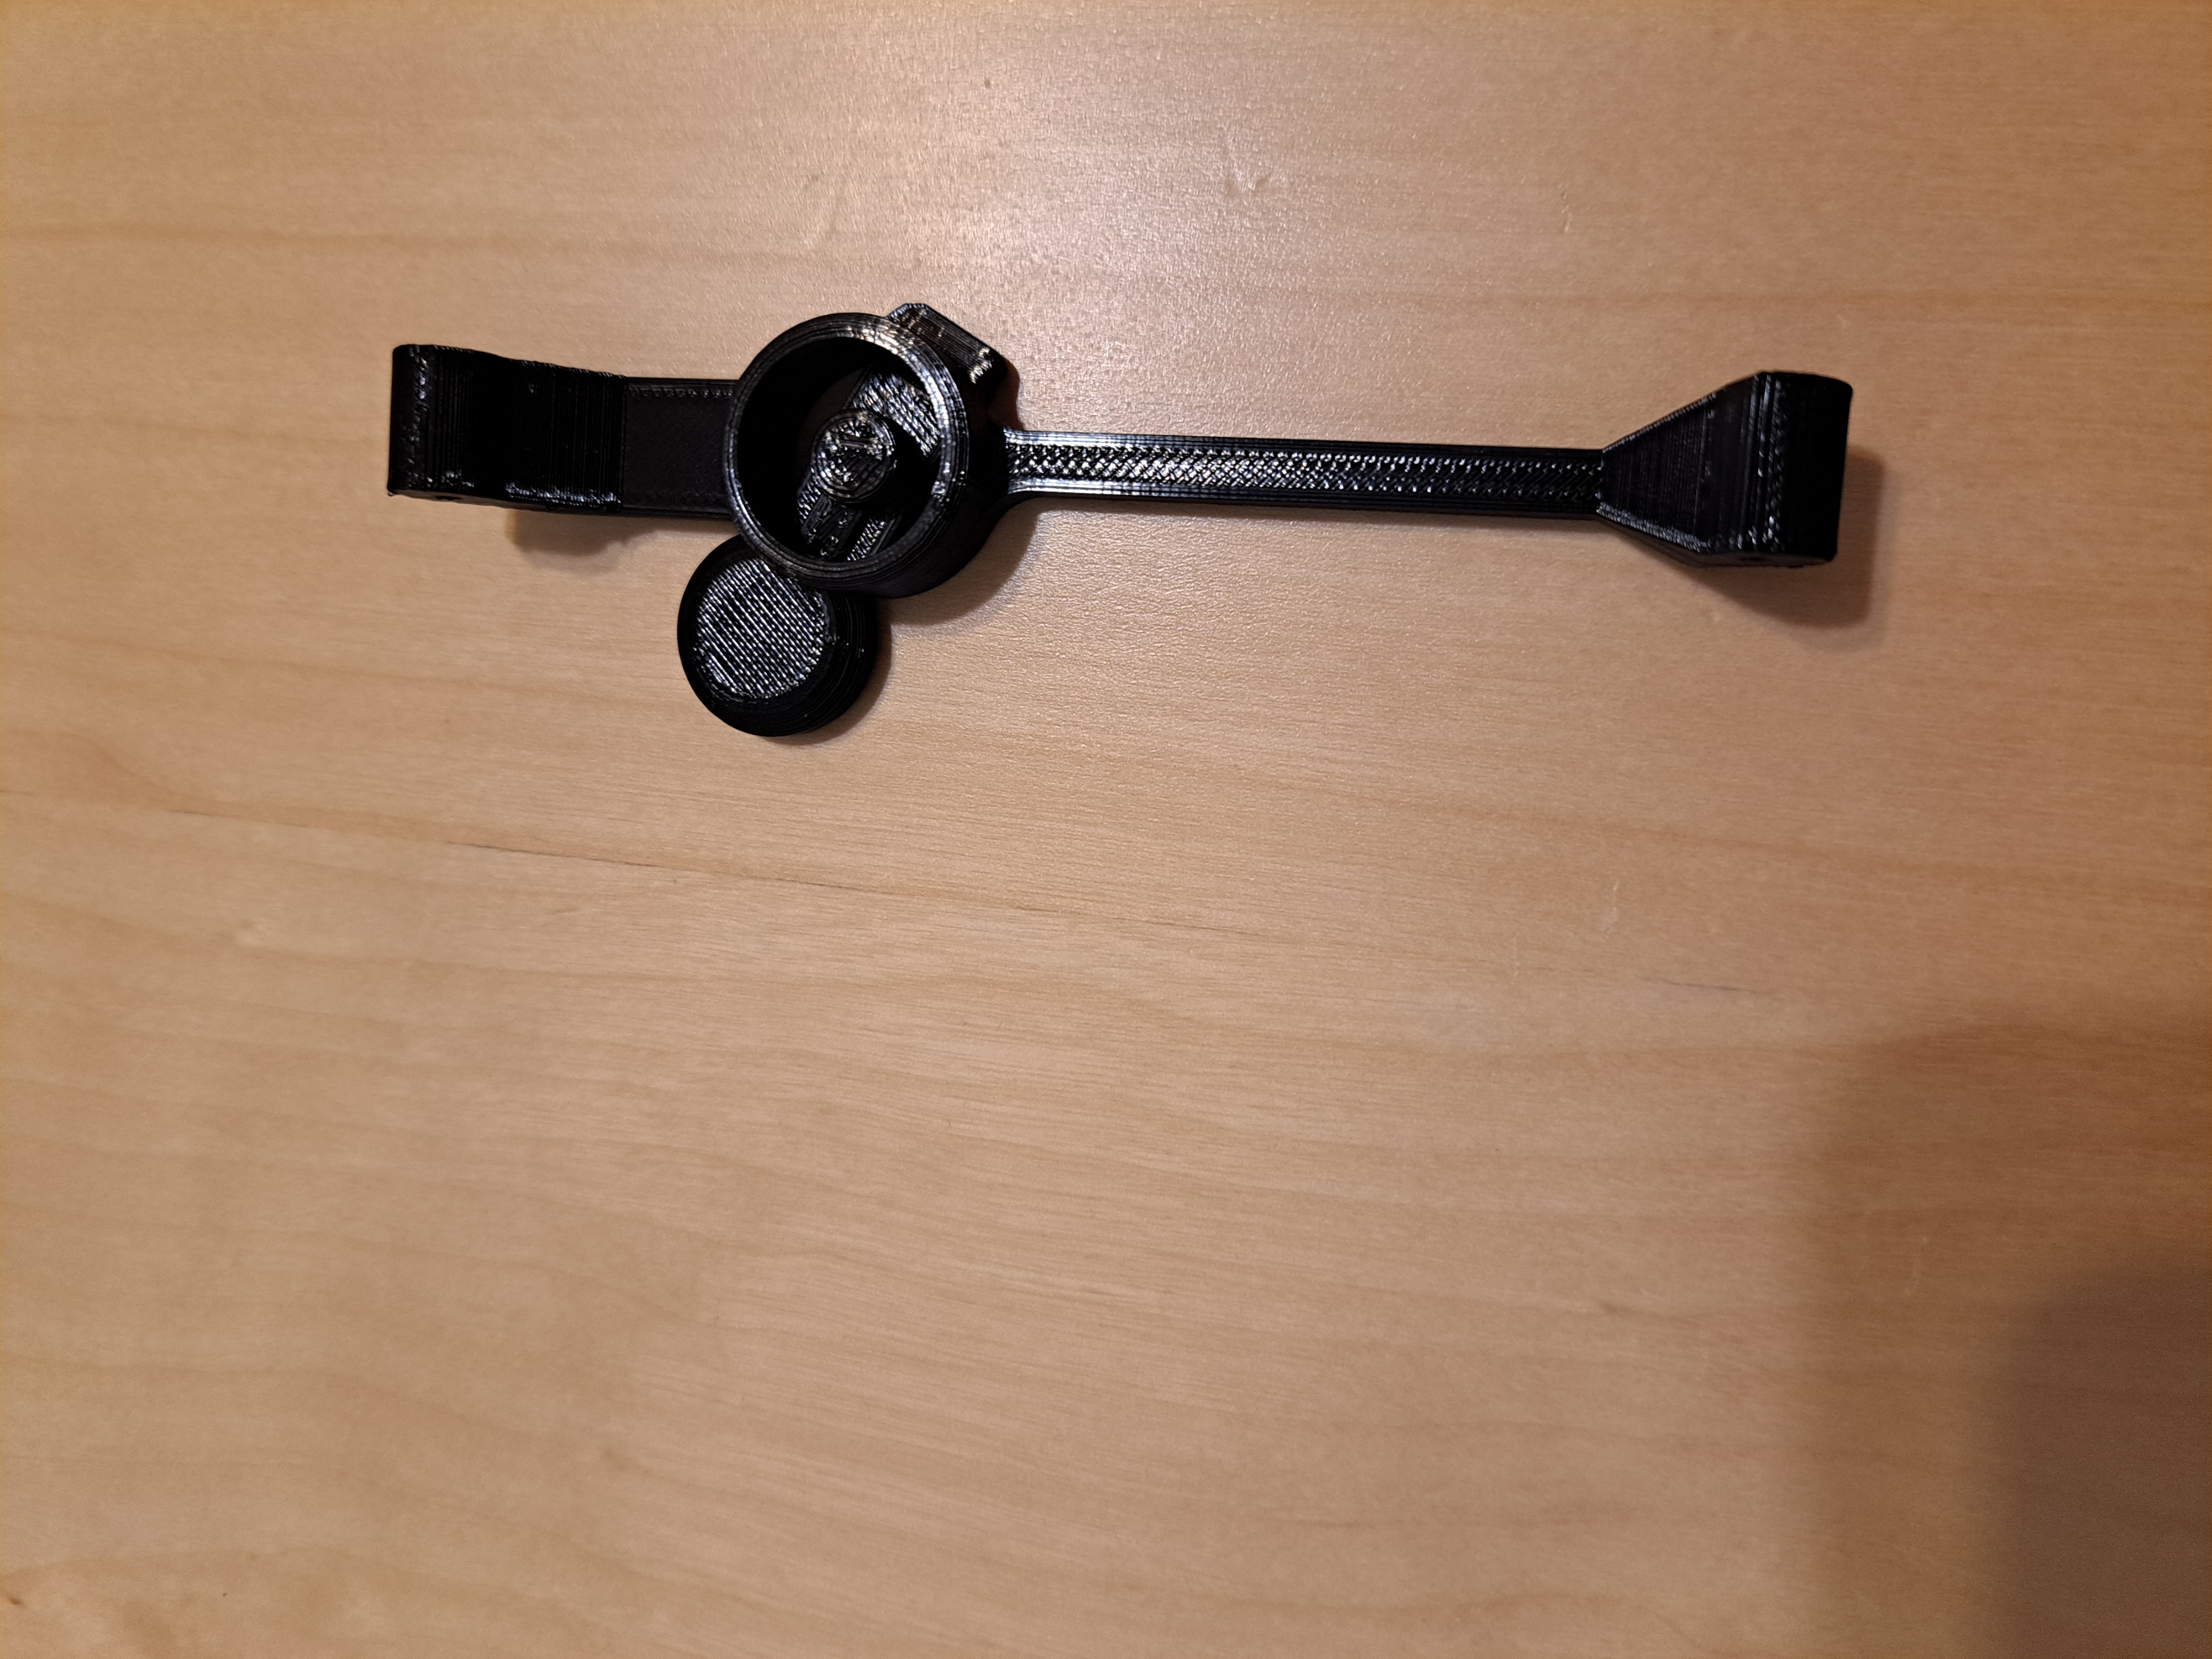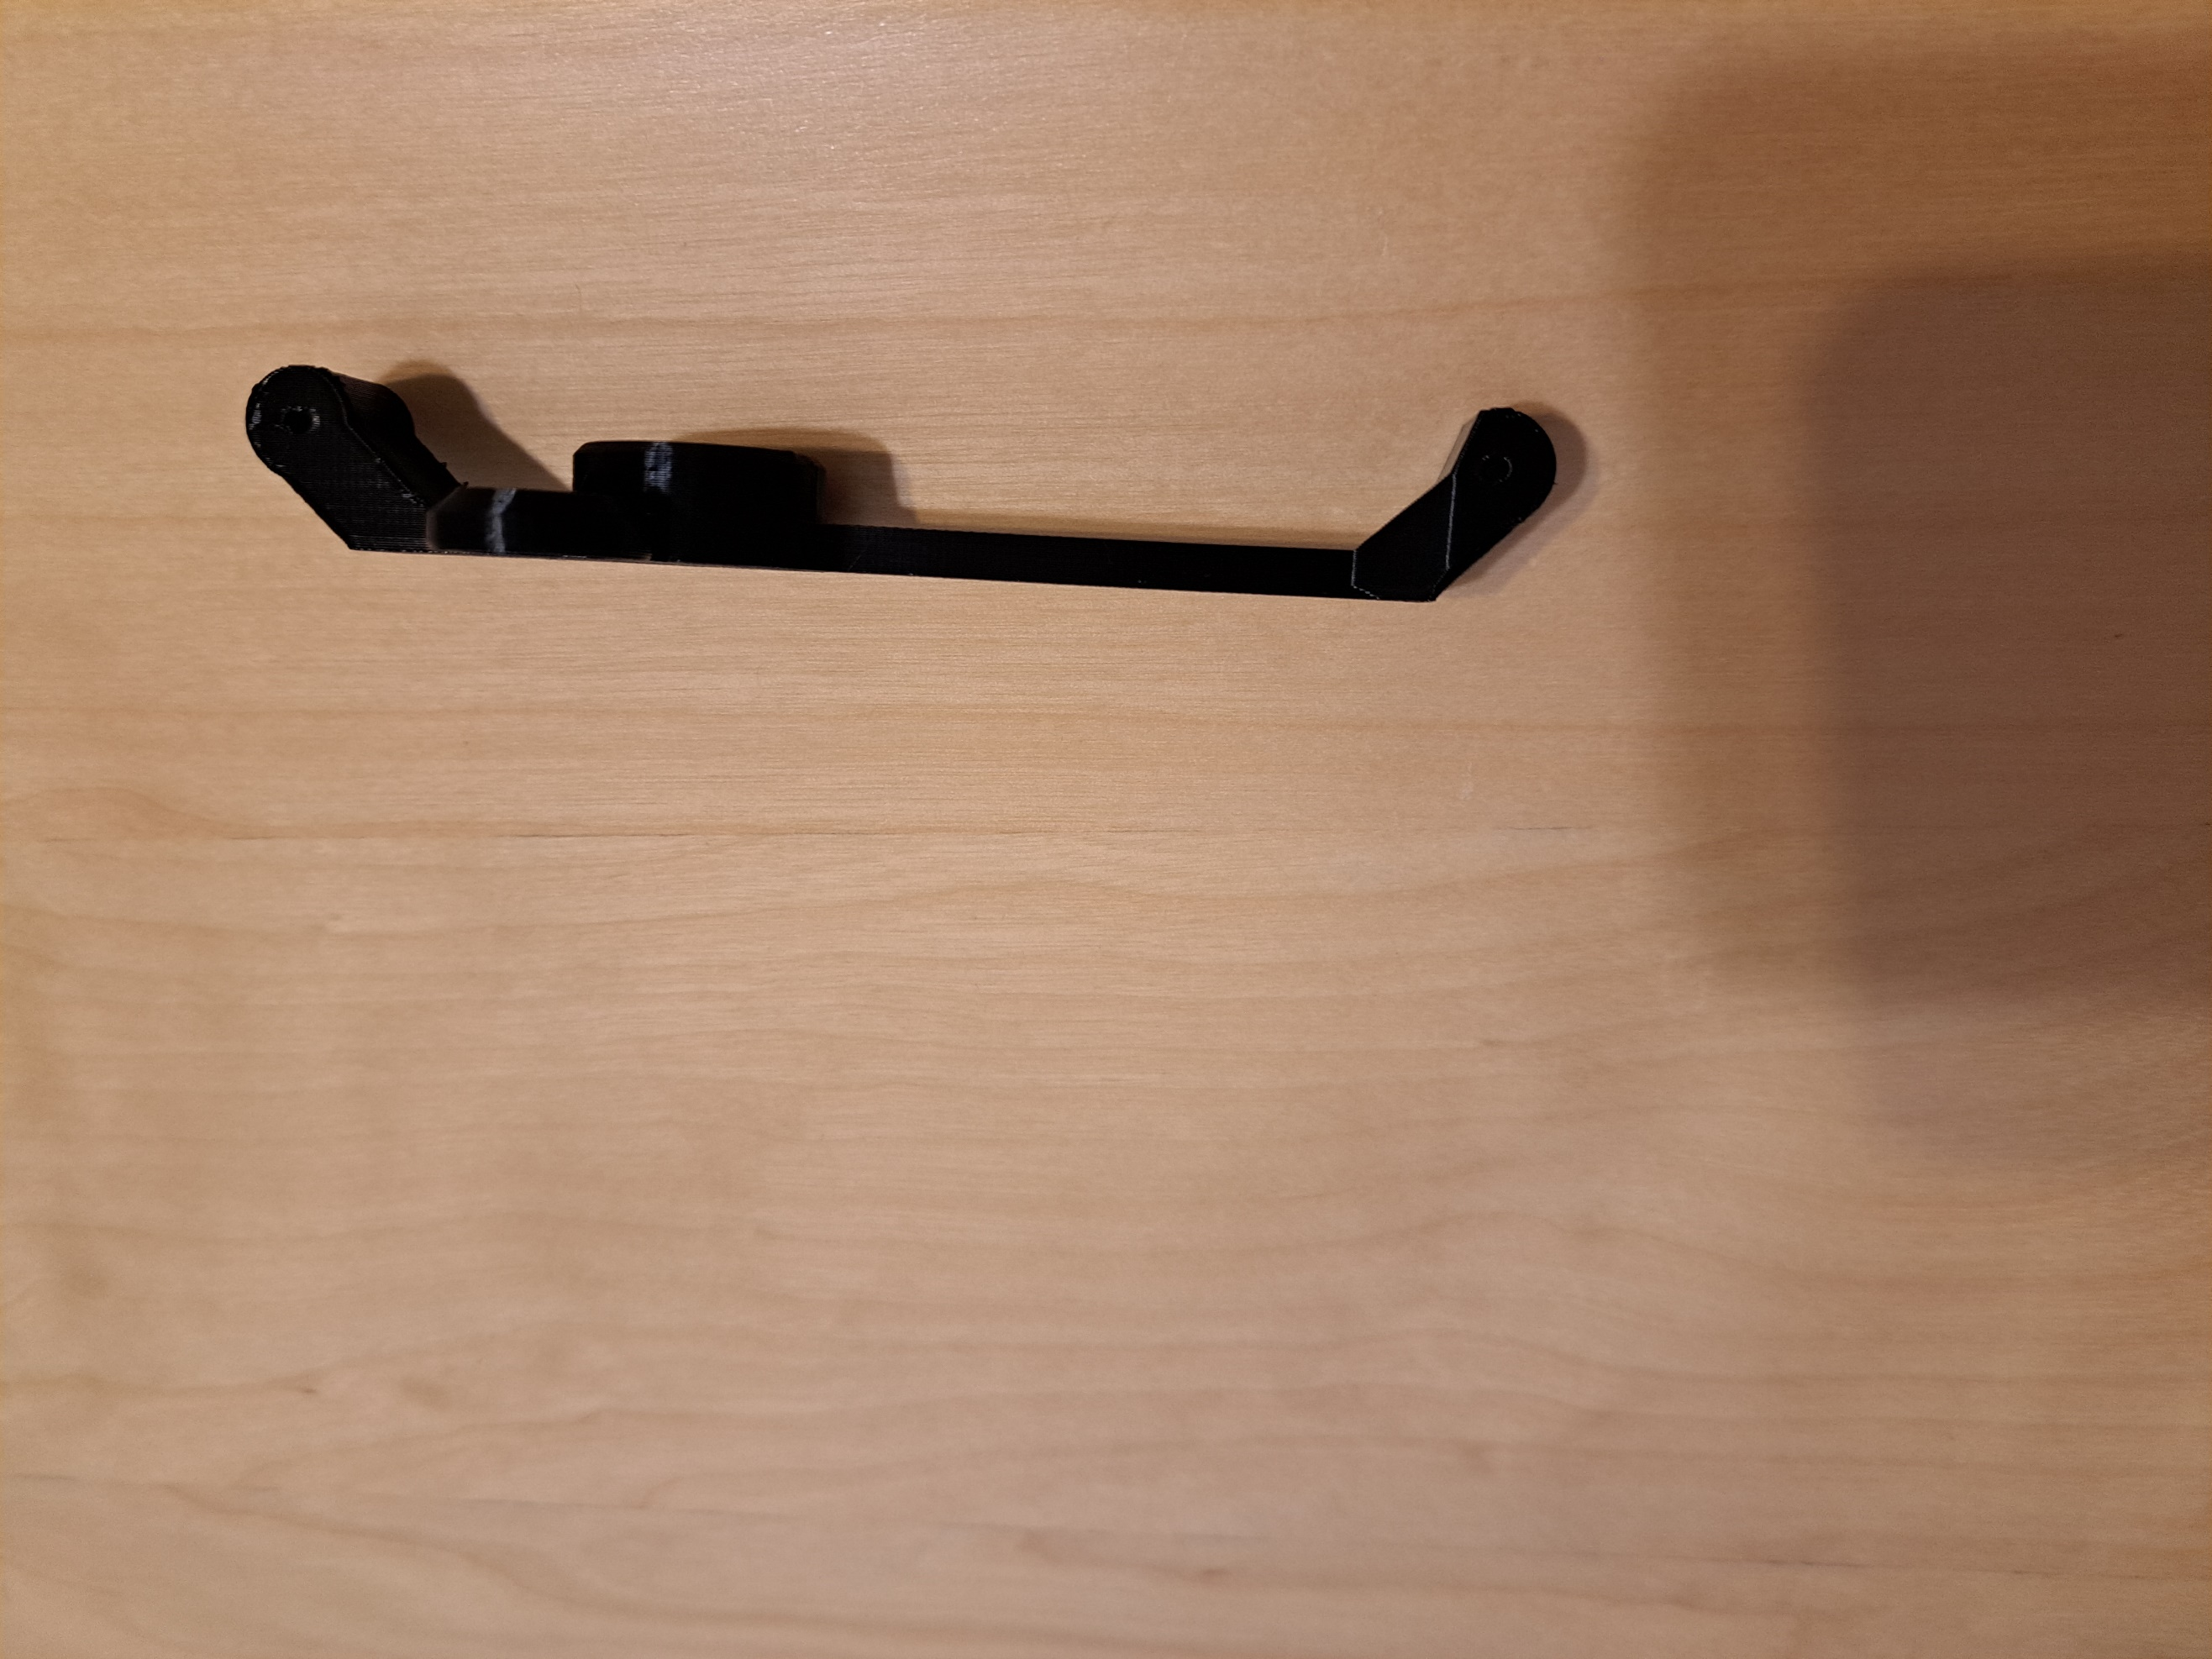

**Mount**

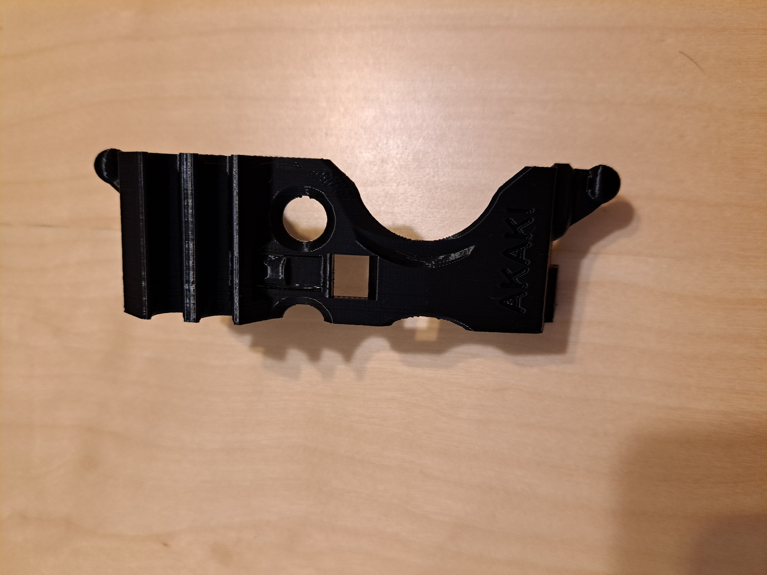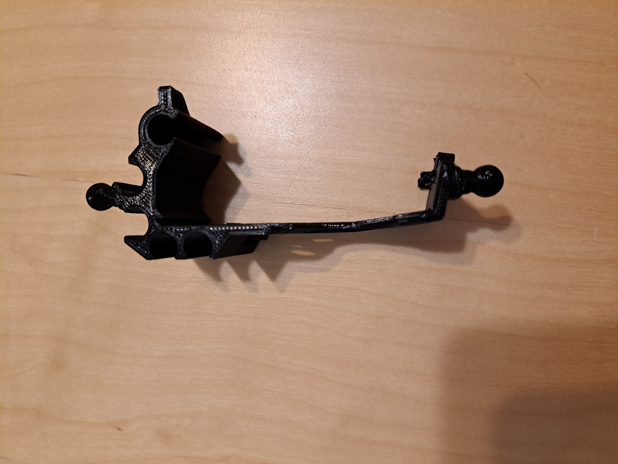

# Assembly Guide

## Required Components

### Right Handed Modification

|  |  |
| --- | --- |
| *All required pieces and tools to build the right handed controller modification. Each piece and tool is labelled with the corresponding number on the BOM.*  **12.**  **11.**  **10.**  **9.**  **8.**  **7.**  **6.**  **5.**  **4.**  **3.**  **1.**  **2.** | **BOM**   1. Thumb-stick mover armature 2. Trigger pusher 3. Leg strap attachment 4. Linkage pieces 5. Leg strap/shoe holder 6. D-pad pusher 7. Mount 8. Button decorations (optional, Xbox logo only) 9. Shoe (optional replacement for leg strap attachment) 10. Rubber bands (optional but recommended if using the shoe printed in PLA) 11. Flush cutters 12. 1.75 mm 3D printer filament 13. Hook and loop strap (not shown) |

### Left Handed Modification

|  |  |
| --- | --- |
| *All required pieces and tools to build the left handed controller modification. Each piece and tool is labelled with the corresponding number on the BOM.*  **12.**  **11.**  **8.**  **9.**  **10.**  **5.**  **6.**  **7.**  **4.**  **3.**  **2.**  **1.** | **BOM**   1. Thumb-stick mover armature 2. Trigger pusher 3. Face button pushers 4. Leg strap attachment 5. Leg strap/shoe holder 6. Linkage pieces 7. Mount 8. Button decorations (optional) 9. Shoe (optional replacement for leg strap attachment) 10. Rubber bands (optional but recommended if using the shoe printed in PLA) 11. Flush cutters 12. 1.75 mm filament 13. Hook and loop strap (not shown) |

## Required Tools

* Flush cutters/scissors
* Sandpaper (optional)
* Superglue (optional)

## Required Personal Protective Equipment (PPE)

* Safety glasses

## Assembly Instructions

See the [original maker’s YouTube video](https://www.youtube.com/watch?v=QOOU2KnhcHA) for detailed assembly instructions. There are chapters in the video so you can skip ahead to the correct modification.

If the holes for the pinned connections are too tight for the 1.75mm filament, you can use a 5/64” drill bit to reshape/increase the size of the holes. The filament should still fit snugly but allow for easy rotation if you do so.

# Testing

Once the device is assembled, ensure all moving pieces move freely and don’t get stuck. If parts are getting stuck or are difficult to move, lightly sand the component until it moves freely. If you move a part multiple times you should start to see wear marks where the part is too tight. These wear marks will indicate the best place to sand. If you have an Xbox Series X|S controller, attach the device to the controller and test the movement. Make sure the button pushers don’t stick and everything moves freely.